JTU10/2024
15th February 2024
Francis Stuart
Head of Employee Relations
HMPPS
By Email only

Dear Francis,

Formal Registering of JNC Dispute: OneHMPPS Design Stage
Further to our correspondence on the 23rd January 2024 (JTU 04/2024) we set out clearly why the Probation Trade Unions requested a pause at the Design Stage before we are able to move forward to implementation.
We thank you for Jim Barton’s response dated 31st January 2024 on behalf of the OneHMPPS project. However, we do not feel that this response provides the necessary reassurances to give confidence to the trade unions that the Design Stage has been carried out with due diligence. Moreover, we believe the proposed remedy suggested in the letter to address our substantive concerns will be a recipe for chaos if it is adopted.
Therefore, we have no other option than to register a formal dispute on the two following grounds:
- “Matching” approach.
We still do not believe that the employers approach to “matching” is satisfactory and will instead place probation staff at a disadvantage to the quantum of roles that are available to be matched to in the restructured organisation.

- Definition of Probation
Linked to the above the Probation Trade unions maintain that we cannot move to implementation until we have resolved the fundamental issue on the “definition of probation”. This issue is of such fundamental importance that we believe the future of the whole OneHMPPS programme is compromised if we cannot resolve it before the implementation stage. As it impacts on individual staff opportunities for roles in the new organisation and moreover the culture of the new organisation.

The proposed solution contained in the letter from OneHMPPS which sets out that any new definition agreed in the future will be applied retrospectively post implementation of the new design. As the Probation Trade Unions we believe that this will lead to considerable confusion amongst staff. We cannot agree to this and any new definition must be mutually agreed before we can move on from the Design Stage to implementation. This will allow for staff to have certainty for which roles they can be matched into

As we are in dispute the status quo must apply before we are able to move forward.

Yours sincerely,

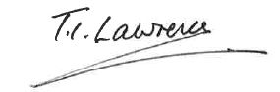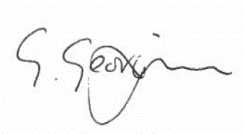

Ian Lawrence Ben Priestley George Georgiou
General Secretary National Officer National Officer
Napo UNISON GMB/SCOOOP

