Interim Custodial OASys Prioritisation Policy

1. Introduction

  - Assessment of offenders remains a vital component of effective offender management (OM). As you will be aware, current operational challenges are affecting the ability of prisons to fulfil their responsibilities with regard to OASys assessments. The backlog is significant, in spite of efforts to address it. Ideally, we would want every eligible offender to receive a full OASys assessment. However, in the current climate, it is essential that OM resources in custody are focused where they are most needed. We are therefore implementing an interim assessment policy in custody, in order to help prisons prioritise their work; to ensure that all high priority offenders do receive a full OASys; and to ensure that all offenders receive at least a risk review. While this document is for prisons and probation, the prioritisation criteria apply only to OASys assessments for custodial sentences, not community orders.

  - This will ensure that:
- the most critical assessments are consistently completed;
- pressure, particularly on local prisons, to process assessments quickly at the expense of quality is reduced;
- more prisoners in the medium/high priority groups should arrive at receiving prisons with an appropriately completed assessment;
- receiving prisons will be able to carry out reviews more quickly.

  - It is important to be clear that this interim policy does not represent an ‘amnesty’ – that is, NOMS is not ‘writing off’ any outstanding assessments. However, the interim policy places offenders into three priority categories for completion of OASys and means that any offender falling into the lowest priority category (Priority C) may be assessed using only a shorter form of assessment known as ‘Risk Review’ within OASys. This will be sufficient to ‘count’ as an assessment and therefore should help to address the backlog,

  - This policy makes no changes to the responsibilities and timescales for completion of OASys ‘start custody assessments (SCA):

- Community Offender Managers from NPS remain responsible for assessing IPP offenders, determinate sentence prisoners who are high Risk of Serious Harm (RoSH), and the initial lifer assessment.
- Prison based Offender Supervisors (including NPS staff in prisons) are responsible for assessing all other offenders (including PPOs and subsequent reviews for lifers).
- As before, those sentenced to less than 12 months do not require an OASys assessment.
- Timescale for completion of initial assessments remains 8 weeks (16 weeks for IPPs if more than 2 years to serve).

  - Reviews are unaffected and can be carried out as now, in full, or as a fast review, but initial assessments take precedence where there is a backlog. This policy does not affect the Basic Custody Screening which is required for all receptions into prisons.

2. Implementation

  - The policy will take effect immediately, for a limited period. It will remain in place until at least 30 June 2015, at which time it will be reviewed. It will be replaced with a final policy once the Offender Management Review has concluded and its recommendations are being implemented. (The OM Review is considering offender management in custody as a whole, including with regard to the future policy on OASys assessments.)

  - To support implementation of this policy, the shorter form of OASys, known as Layer 1, has been enabled for prison Assessors to complete. This can be initiated in the same way as any OASys assessment and completed as a ‘Risk Review’. Users will be able to opt for the Layer 1 assessment from the drop down menu. Assessors will be able to initiate a Risk Review as either a Layer 1 or Layer 3 assessment, depending on whether a previous assessment exists. Information on this process is provided in Annexes B and C.

  - Local prisons must ensure that their OMUs are aware of the prioritisation criteria, and are able to allocate new OASys assessments accordingly to their Offender Supervisors. Resettlement and training prisons must satisfy themselves that they have a process in place to appropriately prioritise in accordance with this policy. For newly sentenced and backlog cases, initial ‘start custody assessments’ (including those undertaken as a Risk Review) must take precedence over reviews.

  - All cases handled by NPS should be treated as Priority A (in accordance with criteria provided in Section 3 below). Community Probation Officers in the NPS must familiarise themselves with the interim Prioritisation Policy and ensure that all OASys assessments that they are responsible for (see 1.4 above) are completed within the required timescales. Wherever possible, this should also take place prior to the prisoner transferring from the local.

3. Priority Groups

  - The following categories have been agreed to enable prisons to prioritise their initial OASys assessments and subsequent reviews. Further guidance is provided below regarding how to identify priority groups and the process to be followed.

Priority A and Priority B – Layer 3 Start Custody Assessment

All of these cases will continue to require a full Layer 3 OASys Start Custody Assessment.

Priority A:

  - Lifers

  - Sexual index offence (sexual offenders require a Risk Matrix 2000 assessment which can only be carried out using OASys Layer 3.)

Priority B:

  - Violent index offence with OGRS score of 25+

  - Non-violent/non-sexual index offence with OGRS score of 50+ and 2 years or more remaining to serve in custody

Priority C – Risk Review, plus full RoSH assessment where triggered

  - For the duration of this interim policy, offenders in this category can be assessed using the ’Risk Review’ option and completing Section 1 (to calculate the OGRS score) and the RoSH screening.

- Violent index offence with OGRS score of <25
- Non-violent/non-sexual index offence with OGRS score of <50
- Non-violent/non-sexual index offence with OGRS score of 50+ and <2 years left to serve in custody

This third category may include newly sentenced prisoners sentenced to up to 4 years, and may also include longer sentences where offenders have already served part of their sentence. For newly sentenced offenders, time remaining will be calculated as per the standard processes for sentence calculation.

  - If the offender is a presumptive Cat D, i.e. presumed suitable for open conditions, and they fall within the criteria set out at 3.2, a Risk Review will be sufficient. I.e. completion of Section 1 (to calculate the OASys score) and a new or updated RoSH screening (and full assessment if triggered).

  - Offender Management Unit Managers will need to identify a light touch process for prioritising new and outstanding OASys for completion, within the categories set out above. Identifying the following critical factors will enable easy separation into high and medium, which require the full Layer 3 Start Custody Assessment, and low, which will require only the Risk Review (and full RoSH, if triggered):
- OGRS score
- Offence type
- Time left to serve.

4. Implications for local prisons

Newly sentenced cases

  - Newly sentenced cases should be assessed as per current timescales, in the order of priority given above. It remains important that the initial assessment is completed prior to transfer wherever possible. This prioritisation policy is intended to enable this as the norm.

  - Where the offender has been given a life sentence or convicted of a sexual offence, they are a high priority case and must then be assessed using Layer 3.

  - Where OGRS has been calculated by NPS at court and sent to the prison, use this information to identify whether the offender is a Priority B or C case. Priority B cases must then be assessed using the full Layer 3 SCA. Where no OGRS score is available, follow steps at 4.4 to determine whether the case is a Priority B or C.

  - For Priority C cases the following applies:
- Complete Risk Review in OASys within 8 weeks of sentencing and before transfer wherever possible:
  - Open Layer 1 in OASys (or Layer 3 if a previous assessment exists prior to sentence)
  - Complete Section 1 (offence details)
  - Complete RoSH screening
  - If triggered, complete full RoSH.
- There is no need to complete or update the sentence plan.

Existing (backlog) cases

  - Where cases are overdue an assessment, the first consideration is likely to be time remaining to serve. Those Priority A and B cases with the least time remaining should be assessed first, in order of priority as set out in section 3 above. For life sentenced prisoners, which are all Priority A, the first consideration should be in relation to the date of next parole hearing. (However, it is unlikely that local prisons will hold these prisoners at that stage of sentence.)

  - Offenders who are potentially suitable for the open estate may be assessed according to the policy. Those who fall into the Priority C group can still be accepted into open prisons if they have an up to date Risk Review, i.e. OGRS and new or updated RoSH screening (and full analysis if triggered).

5. Implications for resettlement and training prisons

  - Where cases are overdue an assessment or review, initial custodial assessments for all priority categories should take precedence over reviews. Those Priority A and B cases with the least time remaining should be assessed first, in order of priority as set out in section 3 above. As above, for life sentenced prisoners, which are all Priority A, the first consideration should be in relation to the date of next parole hearing. (As before, initial OASys falls to the NPS Offender Manager in the community for lifers, whilst subsequent reviews fall to prisons.)

  - Priority A and B cases:
- Where received with no previous assessment, complete Start Custody (Layer 3) OASys.
- Where received with a Start Custody (Layer 3) OASys, carry out a review as per current policy

  - Priority C cases:
- Where received with a Layer 1 and BCST, no further work is required unless a change of circumstances in the case triggers a RoSH review.
- Where received with a Start Custody (Layer 3) OASys completed at the local prison, no further work is required unless a change of circumstances in the case triggers a review of RoSH or the sentence plan. Fast reviews may be carried out.
- Where received with no previous assessment carried out at the point of sentencing, complete ‘Risk Review’:
  - Open Layer 1 in OASys (or Layer 3 if a previous assessment exists)
  - Complete Section 1 (offence details)
  - Complete RoSH screening
  - If triggered, complete full ROSH
- There is no need to complete or update the sentence plan.

Annex A - Prioritisation Matrix for Start Custody Assessments

Indeterminate Sentence Prisoner | PRIORITY A – OASys Layer 3 | PRIORITY A – OASys Layer 3 | PRIORITY A – OASys Layer 3
Sexual Index Offence | PRIORITY A – OASys Layer 3 | PRIORITY A – OASys Layer 3 | PRIORITY A – OASys Layer 3
Violent Index Offence | PRIORITY C – Risk Review | PRIORITY B – OASys Layer 3 | PRIORITY B – OASys Layer 3
‘Other’ Index Offence  2 yrs or more to serve | PRIORITY C – Risk Review | PRIORITY C – Risk Review | PRIORITY B – OASys Layer 3
‘Other’ Index Offence  Less than 2yrs to serve | PRIORITY C – Risk Review | PRIORITY C – Risk Review | PRIORITY C – Risk Review
OGRS | 0-24 | 25-49 | 50+

Responsibility for assessment:
Indeterminate sentence prisoners – Community Offender Manager (NPS)
All other cases – dependent on Risk of Serious Harm level

Annex B – Process for Prison Establishments: Creating a Layer 1 Risk Review Assessment

If there is no previous OASys Assessment, or the previous Assessment is historic or the previous Assessment is Layer 1, a Layer 1 Assessment can be commenced using the Purpose of Assessment “Risk Review.”
Log on to OASys
- Search for offender
- Open Offender Details screen
- Click on ‘Create Assessment’ (just below the main toolbar)
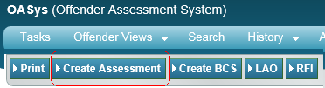

This will open up a new screen
- Select the Purpose of Assessment as ‘Risk Review’
- Select the Assessment Layer (i.e. Basic Layer 1)
- The Sentence Plan Type automatically defaults to ‘Basic’ and cannot be changed
- Select your Team and the Assessor who will complete the Layer 1 Assessment
- Click ‘Create’

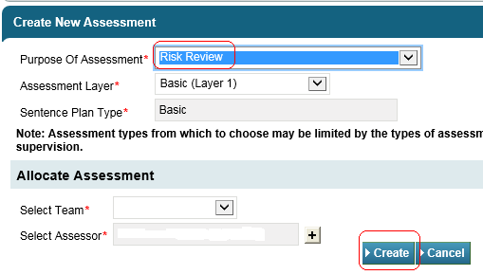
This will create a Layer 1 Assessment for completion 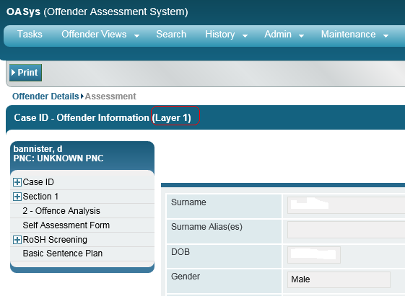

Section 1:
Ensure that the offence details are correct and that the ‘Count’ (see help text for more information) has been entered, as the Assessment will not lock without it.
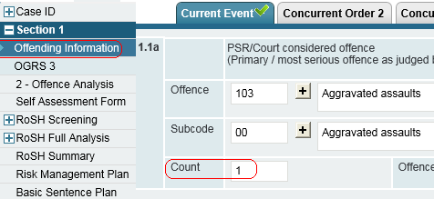

Section 1:
Complete the OGRS 3 (this is important to determine the priority level in Annex A & D)
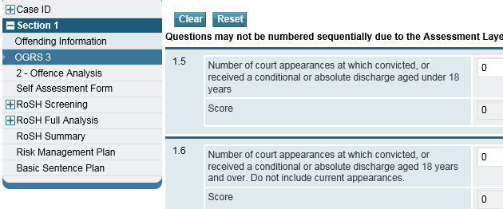

Navigate to the RoSH Screening and complete ALL sections (R1-R5)
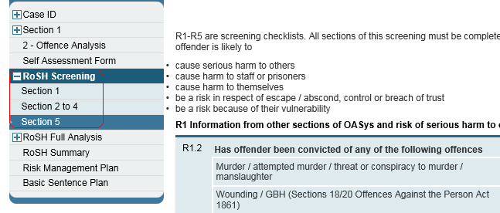

If a Full RoSH is triggered, complete ALL the remaining Risk Sections:
Full Analysis (Sections R6-R9 where applicable)
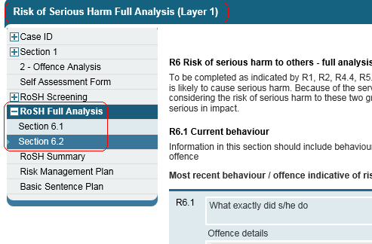

Risk Summary (R10)
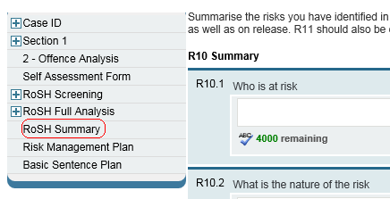

If the offender is assessed as posing a Medium or higher Risk of Serious Harm, the Risk Management Plan must be completed.
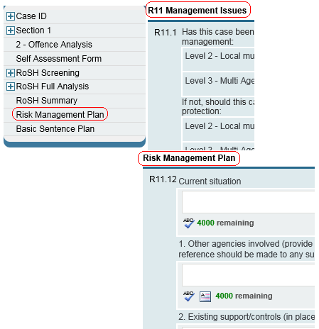

Navigate to the Basic Sentence Plan and sign and lock the Assessment. No further amendments are required to the assessment or sentence plan.

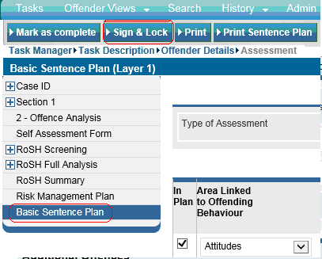

- If the offender is then identified as posing a High RoSH, refer to the Community Offender Manager in NPS for the full Start Custody Assessment.

- If the offender is identified as Priority B (see Annex A), initiate a Layer 3 ‘Start Custody Assessment’ and pull through the Layer 1 ‘Risk Review’ assessment.

Annex C – Process for Prison Establishments: Creating a Layer 3 Risk Review Assessment

If an offender has a previous Assessment which was completed as a Layer 3, subsequent Assessments have to be Layer 3 and Layer 1 is not an option. In order to create a Layer 3 Risk Review Assessment:

Log on to OASys
- Search for offender
- Open Offender Details screen
- Click on ‘Create Assessment’ (just below the main toolbar)

This will open up a new screen
- Select the Purpose of Assessment as ‘Risk Review’
- You can only select the Assessment Layer 3 (as the previous Assessment was Layer 3)
- The Sentence Plan Type automatically defaults to ‘Review’ and cannot be changed
- Select your Team and the Assessor who will complete the Layer 3 Assessment
- Click ‘Create’

This will create a Layer 3 Assessment for completion
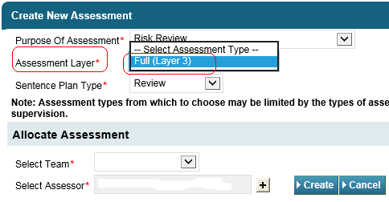

This will create a Layer 3 Risk Review Assessment for completion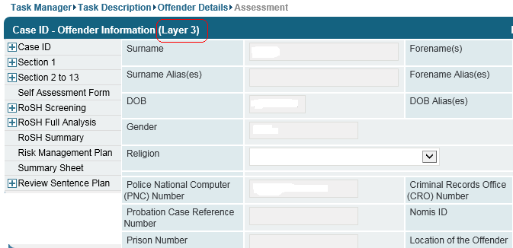

Section 1:
Ensure that the offence details are correct and that the ‘Count (see Help text for more information)’ has been entered, as the Assessment will not lock without it.

Section 1:
Complete the OGRS 3

Navigate to the RoSH Screening and complete ALL sections (R1-R5)

If a Full RoSH is triggered, complete ALL the remaining Risk Sections:

Full Analysis (Sections R6-R9 where applicable)
Risk Summary (R10)

If the offender is assessed as posing a Medium or higher Risk of Serious Harm, the Risk Management Plan must be completed.

Navigate to the Sentence Plan and sign and lock the Assessment as complete. No further amendments are required to the assessment or sentence plan.
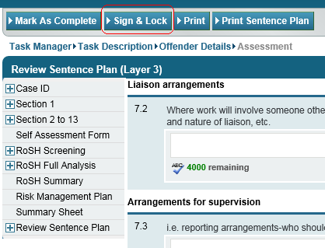

Annex D When to do and who does an OASys Layer 3 Start Custody Assessment

Case
Identify sentence type
Lifer/
IPP?
NPS OM completes Start Custody Assessment
High Risk?
OGRS & RoSH Assessment Updated at sentence?
Full RoSH triggered?
Low Priority? (according to Table)
Index Sex Offence?
OS creates ‘Risk Review’ assessment and updates/ completes RoSH & OGRS
OS completes Full RoSH
No further action
Yes
Yes
No
Yes
No
No
Yes
Yes
Indeterminate Sentence PrisonerPRIORITY A
OASys Layer 3PRIORITY A
OASys Layer 3PRIORITY A
OASys Layer 3Sexual Index OffencePRIORITY A
OASys Layer 3PRIORITY A
OASys Layer 3PRIORITY A
OASys Layer 3Violent Index Offence
PRIORITY C
Risk ReviewPRIORITY C
OASys Layer 3PRIORITY C
OASys Layer 3‘Other’ Index Offence
2 yrs or more to serveLOW
Risk ReviewLOW
Risk ReviewMEDIUM
OASys Layer 3‘Other’ Index Offence
Less than 2yrs to serveLOW
Risk ReviewLOW
Risk ReviewLOW
Risk ReviewOGRS0-2425-4950+
No
No
Yes
OS completes Start Custody Assessment as
High Priority
OS completes Start Custody Assessment as
Medium Priority
No

To access the Risk Review, select from ‘Purpose of Assessment’ when in the OASys system. See Annexes B and C for a description of this process.
Where there is already a Layer 3, it will not be possible to carry out a Risk Review in Layer 1. In this case a Layer 3 can be ‘pulled through’ as a ‘Risk Review’ and only Section 1 and the RoSH sections must be updated; no other parts of the assessment or sentence plan need updating
As per footnote 2.

