BR 63/2015
IL/AV

11 June 2015

To: Branch Chairs, Vice Chairs, Secretaries & Convenors
Family Court SEC (for info)
Cc: NEC Co-Reps
Napo Officers and Staff

Dear Colleague,
Sodexo and the National Staff Transfer Agreement

The Probation trade unions have met twice with senior Sodexo management within the last week to discuss the company’s plans to implement a staff reduction programme and the associated offer for an enhanced early retirement scheme (EVR).

The statement below which was presented to Sodexo last night by the trade unions, makes it clear that the unions believe that the proposals are unacceptable and that we expect the company to honour the terms of the National Staff Transfer Agreement .

As indicated, Napo will be urgently consulting with our Napo representatives from the Sodexo owned CRCs and will be referring the issue to the National Negotiating Council NNC. It has been agreed at this stage that detailed information (on which we are awaiting a final version later today) will be shared initially on an 'in confidence basis' with the local CRC representatives from each of the unions.

I fully appreciate the current uncertainty that our members within the Sodexo owned CRCs are trying to cope with and the wish to see more information. As you might expect, there are a number of hugely complex issues that have arisen from the discussions with Sodexo, and Napo has been working extremely hard to defend your interests. We are also insisting that the contractor should abide by the national agreements that were underwritten by the Secretary of State prior to TR Share sale.

At this stage I am asking that enquiries about the contents of this circular be limited to Sodexo CRC members please via your Napo representative to: Ranjit Singh (rsingh@napo.org.uk).

I will be issuing more news for all Napo members once we have consulted with our Sodexo CRC reps and at the same time as the proposals are released more widely to staff across the CRC's involved.

Yours sincerely

Ian Lawrence
General Secretary
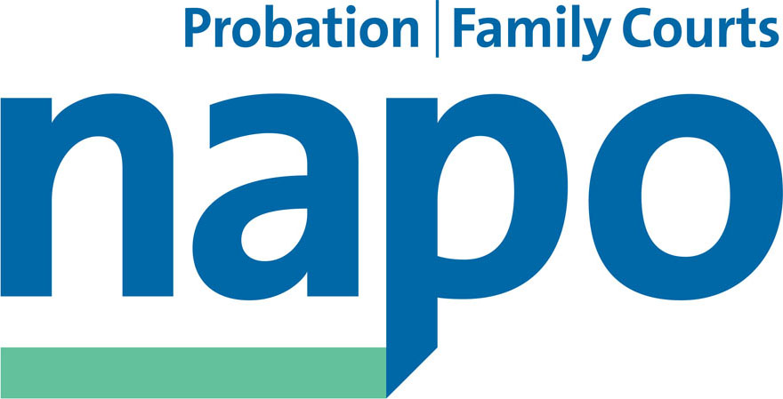



JTU 12-15
10th June 2015

Position Statement

At today’s meeting between Sodexo, Napo, Unison and GMB the trade unions discussed the proposal from Sodexo to vary the terms for Enhanced Voluntary Redundancy (EVR) which is part of the company's plans to implement a staff reduction programme.

The trade unions have made it clear that this offer is unacceptable and that we expect the CRCs under Sodexo's ownership to fully abide by the terms of the National Staff Transfer Agreement. The unions will now be urgently consulting with their representatives employed within the Sodexo owned Community Rehabilitation Companies.

Additionally, and given the complexities of the issues under discussion the trade unions will be referring the situation to the National Negotiating Council and NNC SCCOG for urgent attention.

Until such time as these issues are resolved the trade unions believe that the current pause on the staff reduction plans should continue.

Ian Lawrence Ben Priestley David Walton
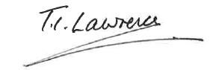
General Secretary National Officer National Secretary
Napo UNISON GMB/SCOOP

