4 Chivalry Road, London, SW11 1HT
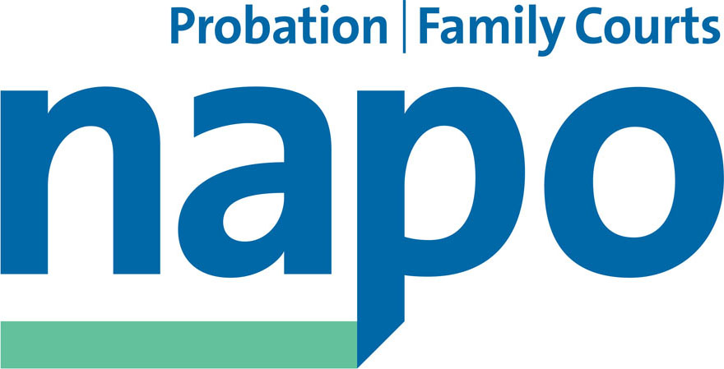

Telephone 020 7223 4887
Fax 020 7223 3503

www.napo.org.uk
Email: info@napo.org.uk

CN 04/2015

Cafcass Negotiating Committee Report
to NEC on 22nd September 2015

The Napo Cafcass Negotiating Committee met on 14th September. We met with management reps for a Partnership meeting on 23rd July.

- Workload Measurement Tool. We previously reported on the time recording exercise which took place from Autumn 2014 until the year end. This used one case per practitioner. After being promised the initial findings in mid-December 2015, we waited until August to see the report. For the first time this recorded in writing the hard work and commitment of Cafcass staff, recognising the goodwill of staff who are working over their hours to keep the business going. The report goes on to say that we go on demonstrating continuous improvement but that efficiencies can only be at single percentage figures year on year. The report noted the staff shortage in 2009 and concluded after detailed analysis that the organisation is now short of 87 full time equivalent practitioners. The report goes to the Board this week and we look forward to hearing their observations on this. We have already put to the members of the Negotiating Committee a revised workload weighting structure, based on the findings of the study. Our initial examination of the changes suggests that they will produce an improvement and should show fairer more accurate position. Eg cases with 3 or more children are to be allocated more points. We hope that the majority of adjustments can be made in November and that the others will be introduced following the net update of ECMS.

- Estates issues: Cafcass offices are due to close in Bodmin. Staff will relocate to Plymouth (32 miles) /Exeter (55 miles) / Truro court (27miles). In March 2016 the Basingstoke office will close and staff will work from Portsmouth (50 miles away) or use local borrowed interview facilities. Canterbury is due to close in March 2016 and staff will work from local borrowed workplaces or the Chatham office (29 miles away). The York office will close and relocate to suitable premises in York.

- I.T. The NEC will recall that in July we reported the outage of the Electronic Case management system for up to three weeks for practitioners. Cafcass is now almost paperless. The outage resulted in staff not being able to locate even a phone number or address for service users. As the problem areas were isolated, tremendous pressure was placed on some IT and helpdesk staff to support practitioners with information. Survey Monkey questionnaire was circulated to assess the impact on staff and we are still waiting the results. We know that staff were anxious about the time taken to catch up and fearful of auditing and being put into performance measures if gaps in case files were noted. All practitioners have Blackberries and no admin support for leaving messages. There will be a steep learning curve for many when these are replaced by smartphones in October 2015. The applications on the phone should allow access to individual case files which further adds to the flexible working strategy for which Cafcass continues to win awards.

- Discussions around the Advanced Social Worker grade (linked to last year’s pay claim) became quite complex and discussions are on the back burner. There are concerns that a new role will lead to division amongst members. We are about to consult members about this year’s pay claim and not feeling optimistic at the prospect of increased National Insurance contributions absorbing anything up to a 1.5% pay claim that might be achieved. The initial sounding of members suggests that they want to press for what they feel we deserve which is much more than 1.5%.

- Policy Review. We are almost a year into the revised “Management of Absence” policy. We are concerned at the rate at which staff are processed through the stages of the policy relating to sickness absence, even where there are clear indications that the health of our members will improve and allow them to return to work. We have recently had the support of a national rep with two members at the final stage of the procedure and at risk of losing their job. Both are happily back in work after formal hearings. We are pursuing recent reports of staff being advised to call in daily while off sick which is contrary to the policy requirements.

We have met recently to negotiate a “Management of Organisational Change” policy which will consolidate and streamline the 3 existing policies on Restructuring and Redundancy, Mobility and Relocation. We are near to completion although members will be concerned to know that there is a proposal that excess mileage following relocation is paid for one year rather than the current policy of two years. Given that staff have the technology to work flexibly, it may not have the greatest potential impact although reduced attendance at the office is likely to bring increased isolation for staff. We are asking for the reason for this proposal and for the potential savings to be disclosed as the reduction is not justified. There seems to be no reason other than to be seen to be following other areas within the MoJ. There are no changes to redundancy payment terms and we hope that this will be clearly set out in the revised policy as it is in the current policy. We are particularly pleased that great emphasis is given to recognising and supporting the particular pressure on local and line managers during change and the critical importance of giving them an opportunity to be involved in discussions around changes which they will be expected to implement and lead on. We expect to conclude discussions shortly and await a final draft.

- The Cafcass budget and post-election spending review. The potential cuts are feared at all levels following continual streamlining exercises. We await the final budget news.

- New staff induction packs. We hope to include better information about Napo membership in this re –draft. Ideally we would like to see links to the Napo website and membership page. This would support the recruitment of new members to Napo and allow the employer to openly support the commitment to partnership working. The committee members welcome the renewed recruitment drive and forthcoming new promotional material and will promote the new sign up to direct debits; all of which should secure our infrastructure for the future.

