HS 04-2020
Napo guide to Covid-19 risk assessments

General principals of risk assessment
Assessing risk is something many of our members do as part of their work in family courts and probation. The terminology may be different, but the principles are the same irrespective of what is being assessed. The core principals of health and safety risk assessments are to identify the workplace hazards, evaluate the risk level of the hazards and to put in place control measures to deal with the risk.
Covid-19 risk assessments should be in place for all sites where our members work - and have had appropriate trade union involvement.
Employers have an absolute duty to conduct a “suitable and sufficient” risk assessment under the Management of Health and Safety at Work regulations.
What is meant by “suitable and sufficient” is not defined in the legislation but to meet this standard any risk assessment should identify hazards, determine the likelihood of injury or harm, identify any specific legal duty relating to the hazards, remain valid for a period of time and enable decision to made about appropriate control measures.
The templates employers use for risk assessments differ, but the same principles apply. Working from the generic risk assessment the risk assessor and the Napo safety rep will ensure that the generic assessment is adapted to suit each individual workplace, identifying different control measures necessary.
A “competent person” must carry out the risk assessment. The definition of what constitutes a competent person is that they must have had sufficient relevant training, experience or knowledge.
It is employers’ absolute duty to write the risk assessment – it is not the role of the union rep to do this. But safety reps must be involved in the risk assessment process – including working with the risk assessor. As our safety reps know best how the workplace operates and therefore the employers should be draw on their knowledge. This does not mean that there is any legal onus on the safety rep - there can be no comeback on the rep for any deficiencies in the assessment.
HSE 5 steps to risk assessment
The HSE 5 steps to risk assessment is useful tool as it sets out step-by- step approach to risk assessment:
Step 1: Identify the hazard(s).

Step 2: Decide who might be harmed and how.
This could include staff, service users, contractors etc.
Then you need to think about how will they be exposed, for example by direct contact with droplets from an infected person or touching a person, surface or object which has the virus present?

Step 3: Evaluate the risks and decide on precautions (usually known as controls)
(NB: A hazard is something with potential to cause harm or injury. A risk is the likelihood of harm or injury arising from a hazard).
Evaluating the risks would mean rating the risk of infection occurring during undertaking the task, schedule, job etc.

The risk evaluation is likely to be calculated using a formula, such as Likelihood × Severity = risk level.
The outcome will be a score that determines the level of risk for each part of the risk assessment and whether it is low, medium or high. This is the most reliable means of assessing risk levels and more meaningful than attaching a word like ‘moderate’ to a risk without being able to back it up.
However, there will still be a level of subjectivity involved in this process and therefore the risk assessor should speak to those who know the workplace best – the workforce and their trade union representatives for their views.
Precautions/controls to protect workers should be selected using a hierarchy of control (see below for more information).

“As low as is reasonable practicable” is the principal that is applied when considering risk assessment control measures. It means that the degree of risk in a particular situation is balanced against the time, trouble, cost and physical difficulty of taking measures to avoid the risk. So the risk to staff and others needs to be assessed and then proportionate measures applied to prevent these risks causing harm.

In relation to the Covid-19 risk assessments the “as low as is reasonably practicable” principle must also factor in Government/NHS/ HSE/Public Health England/Scotland/Wales and Northern Ireland advice re Covid-19 and continue to take this into account on an on-going basis as this advice is constantly evolving.

Step 4: Record the findings and implement them.

Step 5: Review the risk assessment and update if necessary
Make sure that this is done – and that you are involved in this process. A review could take place when…..
Hierarchy of control:
Napo advocate that a hierarchy of risk control (as illustrated below) should be used when undertaking risk assessment activities, to control hazards and minimise risk.

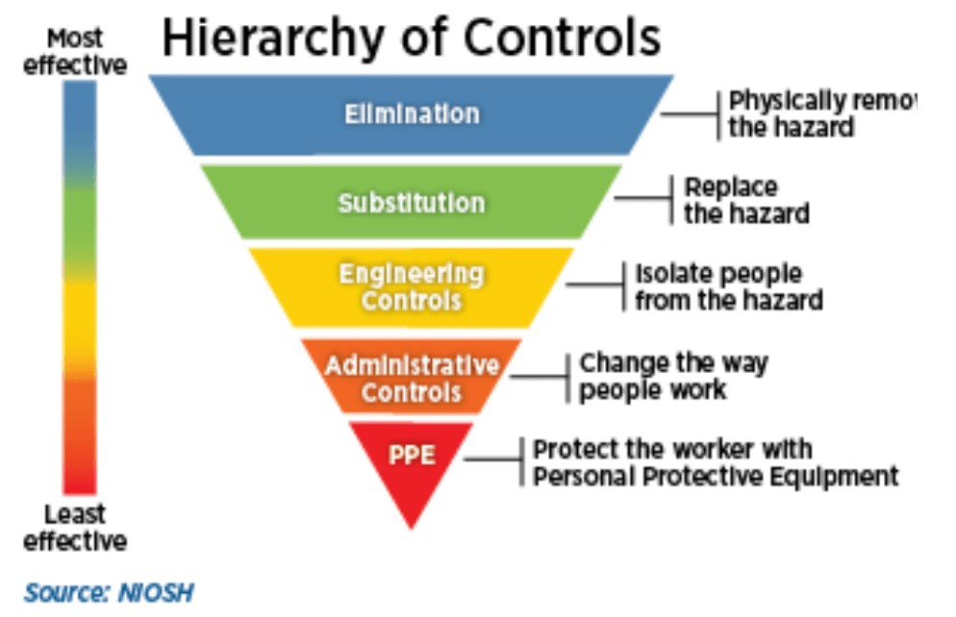
You can see from this diagram of the hierarchy of control, that the most effective approach to controlling risk is at the top – and it is this that should be considered first and the least effective is at the bottom, to this should be considered last. Therefore employers should not just be using the control methods that are the easiest for them to implement.
- Elimination
This could be through a vaccine, or through complete isolation, such as lockdown. Another example is those who were shielding.

- Substitution/reduction
Reduction could be applied as follows:
- Social distancing. This control needs to be implemented stringently in order to be effective, together with good hygiene practices, both personal and in the workplace.
- Those with symptoms (no matter how mild) to leave the work place immediately.
- Isolation of workers that become ill
- Zoom, skype meetings etc……rather than face to face meetings.

- Engineering Controls
Barriers
- Place a physical barrier such as a Perspex screen, flexible polyethylene sheet.
- Demarcation lines 2 metres or more will assist staff in keeping within social distancing requirements.
- Demarcation areas combined with physical barriers (see below) where they can be applied, is a good combination of controls when re-enforced with appropriate messages and training.

Ventilation
Lots of evidence has now emerged of how the virus is spread and this particularly relates to indoor workplaces. Therefore greater importance is now placed on control measures such as face masks and good ventilation.
The re-circulation mode of air conditioning should be switched off by facilities management.
Seek advice from your employer re wall mounted/ceiling mounted units or portable air con.
Use of individual desk fans is not encouraged – except on individual risk assessed basis.
- Administrative Controls
This is towards the bottom of the hierarchy of control as you need to have reminder for this behaviour to continue.

Systems of work and procedures
Note: The following measures will need to be applied collectively, together with engineering controls when needed, and PPE provision when the assessment advises this.

- Reducing time spent performing an activity
Limit time in close proximity to other staff/service users to reduce the potential risk - this will ensure PPE is not worn for extensive periods. Where staff are working within 2 meters of another member of staff/service user there the assessment should identify why the task needs to continue, or if it can be abandoned or postponed. If the employer decides it will continue, then follow the hierarchy of control and it may be necessary to put in place barriers – or if not practical for PPE to be used.

- Workforce planning
Personnel could be paired or buddied to compartmentalise potential infection within the work teams.

- Cleaning
Undertake enhanced cleaning, for example with touchpoints in the work area.
Deep clean the workplace prior to re-opening.

Seek agreements on who will clean what, remember our members are not trained to clean or provided with sufficient PPE. With the HMPPS we have agreed that in interview rooms after each interview, the probation member of staff will wipe down their side of the room with wet wipes and gloves and the service user will be asked to clean their side. If the service user refuses to do this, then the interview room must be declared out of use until such time as it is cleaned by FM cleaner.

- Personal Hygiene
Maintain high levels of personal hygiene wash hands regularly for 20 seconds.
- PPE (Personal Protective Equipment)
PPE is acknowledged as being at the bottom of the hierarchy due to its inherent limitations – because if this fails then there is no other protection – and it reverts to danger.
It is the employers’ duty to pay for PPE. There are specific requirements for certain PPE in APs and when carrying out first aid.
In relation to face covering/face masks issues.
Members who may have particular difficulties in fitting face coverings or face masks (perhaps due to a disability) or cannot wear face coverings or a mask due to a disability must raise this with their line manager as part of their individual risk assessment”.
Checklist for Covid-19 risk assessments:
- Are all staff aware of the contents of the risk assessment? And are they reminded of the contents on a regular basis?
- Is there a review date for the assessment?
- Is it clear in what circumstances the risk assessment will be reviewed? (this should be done for example if workplace circumstances change, or there is an incident which leads to work practices being reviewed)
- Does the risk assessment cover first aid arrangements? And provision of adequate PPE?
- Does the assessment set out how staff can safely take their breaks and eat lunch?
- Does the assessment explain how fire drills will be completed allowing for social distancing?
- Does the assessment cover mental health, welfare factors? And support that may be needed during the recovery stage?
- Are staff being encouraged to raise issues that were not previously considered to be health and safety risks? (risk assessment should be a dynamic process).
- Are equalities issues such as the impact on disabled staff, pregnant women and maternity and the recognised factors relating to BAME staff taken into account?
- Is there clear signage re social distancing and handwashing throughout the workplace?
- Is there enhanced cleaning of all areas?
- Is there provision of adequate PPE and sufficient wet wipes and hand sanitiser?
- Is there guidance on use and disposal of PPE?
- Is the PPE kept in a secure storage area?
- Is there clear signage in parking areas to maintain social distancing and remind employees of the importance of not attending workplaces if they are symptomatic?
- Are handwashing facilities or sanitiser provided at entrances and exits?
- Are areas where there is likely to be a cluster of people, identified by using 2m markings for social distancing requirements?
- Is there internal pedestrian one-way system for any aisles less than 2m with agreed flow, maintain emergency exits and fire doors (closed).
- Is there provision of an isolation area where any employees showing symptoms can be directed until they are able to leave the site? Do all staff understand what should be done in such circumstances?
- Are numbers using the toilets at any one time restricted?
- Is there provision of sufficient soap, hand sanitizers and paper towels?
- Kitchen areas and staff rooms – is the number of chairs minimised to maintain 2m rule?
- Are staggered breaks used to limit number of people in the area?
- Are rooms labelled to identify maximum number of people to respect social distancing requirements?
- Is there a distance of 2m between desks?
- Is there signage and/or floor markings to highlight the importance of social distancing?
- Has your employer carried out risk assessments for individual staff members, particularly staff in high risk or vulnerable groups including Black workers?
- Has the employer risk assessed factors such as ethnicity, age, disability and sex? And/or any underlying health conditions?

Finally
Safety reps should not sign off risk assessments – this is the employers’ responsibility. But if you are supportive of the risk assessment – then let your employer know accordingly.
Safety reps should check and challenge risk assessments if necessary – to make sure that safety measures are in place and are working. The risk assessment is a dynamic document.
Covid-19 risk assessments should be reviewed and revised as necessary in line with changes in current advice - and this is to be done involving staff and their Napo reps.
Remember, you can ask for the risk assessment to be reviewed when for example workplace circumstances change, or there is an incident which leads to work practices being reviewed - or if the assessment is shown to be not fit for purpose. Such problems may only come to light when greater number of staff and service users return to the workplace. The risk assessment is not set in stone – ask for it to be reviewed and revised and to be involved in this review process.
There should be arrangements in place for workers to have access to risk assessments and to be able to challenge and question them.
New inductions and training packages need to be in place to continue to keep all staff aware of what is in the Covid-19 risk assessment.

In shared premises, there is a requirement under the Management of Health and Safety at Work regs, for the employer to take all reasonable steps to inform the other employers of the risks to their employees' health and safety arising out of their undertaking – these risks will have been identified by the risk assessment.

Plan, Do, Check, Act (PDCA)
PDCA is used as four step method for control and continuous improvement of workplace health and safety processes. It is a continuous cycle. Therefore, because knowledge of the virus, Government advice etc. is constantly changing, Napo safety reps should work with their employer on this continuous PDCA cycle. This work should be led by the competent person - but with the involvement of the safety rep.

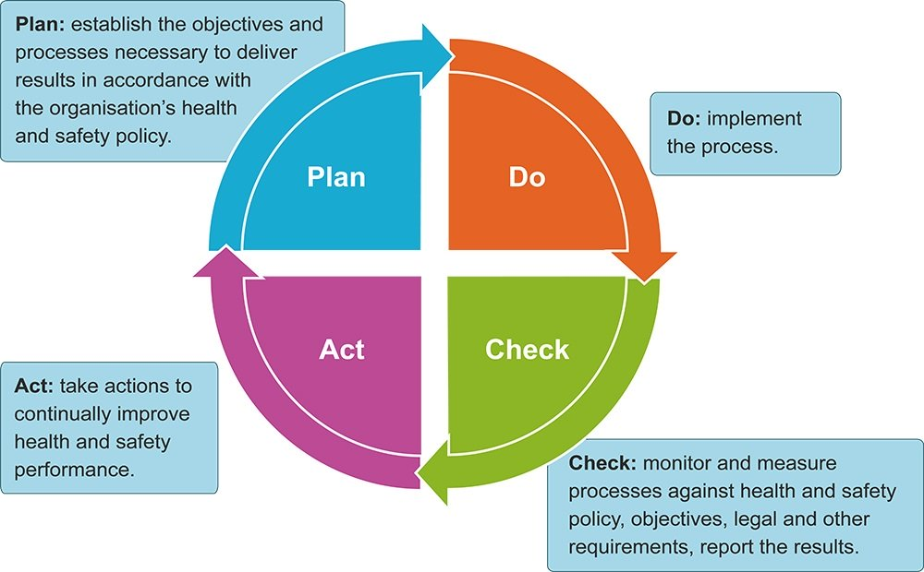
Particularly important for Napo safety reps in relation to PDCA are the check and act stages of PDCA. The check stage of PDCA can be achieved by looking at Covid-19 incidents/accident incident report – and also by taking a pro-active approach to carrying out checks by carrying out safety inspections. If problems are identified from these activities, then the risk assessment may need to be reviewed and revised. It is the competent person that will lead on the PDCA process – but the Napo reps should be involved also.
Conclusion
There is a lot here. But don’t worry there is help and support available from your branch - and from head office.
Also, we are campaigning to recruit a Napo Covid Contact in all workplace. The Covid contacts will be a great help to your role as a Napo safety rep – to be your eyes and ears in workplaces. So please encourage any colleagues who you think might be interested in the role to volunteer by emailing jparyag@napo.org.uk, with their name, workplace and employer.
Sarah Friday
Napo National Official (health and safety)
Updated 2020

