4 Chivalry Road, London, SW11 1HT
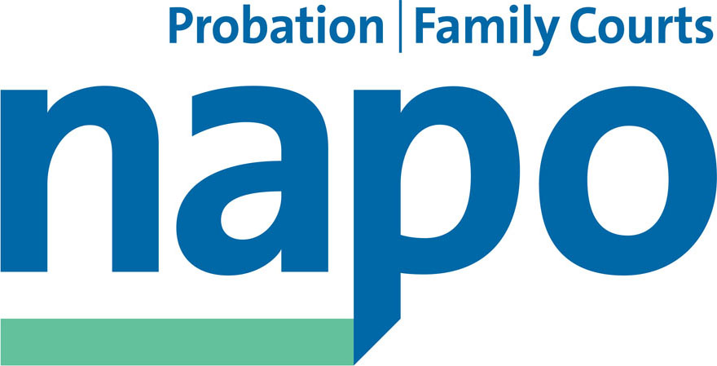

Telephone 020 7223 4887
Fax 020 7223 3503

www.napo.org.uk
Email: info@napo.org.uk

IL/AV 136-14

Via email

Name _ Address Block

15th December 2014

Dear Name,

1. I wrote to you on 11 December 2014 seeking to arrange a meeting or telephone conference to discuss what systems you will have in place to ensure the safety of our members and the public after you take over operation of the CRC(s) you are buying on 1 February 2015.

2. As I indicated last week, Napo are the trade union and professional association representing the majority of trade union members within the Probation service. As such, we expect to engage positively with CRC owners through the agreed negotiating structures, with a view to protecting and promoting the pay, terms and conditions of the staff whom we represent.

3. I am sure that you will also appreciate that we have a wealth of professional knowledge and experience that we would expect to draw upon to protect our members (e.g workloads as per paragraph below, but it is also knowledge and experience from which you as prospective purchasers could benefit from in terms of hearing things that have perhaps been hidden from you by the MoJ. I have outlined these issues below as we believe we are bound to advise you of them.

4. We want to ensure that we work with you on these issues now, before the transfer takes place, so that you have enough time to address the issues which cause us concern.

5. We are writing now to explain in more detail the nature of the issues which concern us. We would therefore welcome an early opportunity to discuss these with you. We would like to ensure that you have them at the forefront of your mind as you plan how you propose to operate. Unless you have been made privy to this information by the Secretary of State we want to make sure that before you sign the terms of contracts, you have enough information about the risks which both we and the Secretary of State (separately) have identified in the system as it currently operates. We want you to understand the systemic risks you are taking on, and to ensure that, before you sign contracts to take over responsibility for those risks, you are satisfied that you have adequate resources to put in place the measures to address them.

6. We want to negotiate with you so as to ensure that, after transfer, there are adequate management instructions and protocols in place to ensure that our members are not asked to work in ways which expose them to serious risks of avoidable harm to their physical or mental health. (You will be aware that this is the common law duty which employers have to ensure workers’ safety).

7. We think it only fair to explain to you the background to this letter and to this voicing of concern. As you may well be aware, Napo has been in correspondence with the Secretary of State for Justice over a number of months expressing concern that aspects of the new structure of the probation service may expose staff, the public and offenders to unnecessary risks of harm. Napo sought the engagement which we have traditionally enjoyed with NOMS over such issues. We repeatedly asked to be allowed to see the Secretary of State’s safety testing and assurance results so that we could engage with him on the substance of our safety concerns in a meaningful and informed way. Unfortunately, despite numerous documented requests over the summer and autumn, Napo was not allowed access to the Ministry of Justice’s safety testing information (not even on a confidential basis). This left us in a situation where we could not provide input informed by the safety testing results as to how to solve some of the problems which were clearly emerging on the ground.

8. During that time, more and more examples emerged of cases in which probation staff were asked to do jobs for which they were not equipped, or to take on too many cases as a result of serious staff shortages and rising sickness levels, or in which CRC staff were asked to meet clients without proper computer access to safety records. In some cases, these problems had resulted in serious physical or sexual assault or psychological breakdown. Examples include a member of CRC probation staff seriously sexually assaulted after she was unable to obtain timely access to risk records which would have warned her not to see that offender alone, and two documented cases of murder after inadequately trained and overworked probation support staff were asked to take on inappropriate serious cases.

9. Napo was worried, on the basis of feedback from its members, that these risks were not being properly recognised or addressed by the Ministry of Justice in its secret safety testing procedures. On 20 October 2014, we sent the Secretary of State witness statements from our members giving examples of these concerns. Copies of these example cases can be made available if you would like to see them.

10. Our members are very seriously worried that after ‘dual access’ to computer systems is switched off on handover of CRC shares, CRC staff will not have adequate and timely access to sufficient risk management information to enable them to work safely; that there is insufficient clarity in arrangements for appropriate and timely transfer of cases between the NPS and the CRCs and the safety consequences of transfer in these circumstances in the context of very serious nation-wide, endemic shortages of suitably qualified and experienced staff and extraordinary rates of stress-related absence.

11. The Secretary of State said that transfer would not take place until he believed it was safe to do so, but was not prepared to explain to us or our members how these safety issues would be addressed and why we should be reassured that he would have taken steps to make sure that these problems were solved so that the system was safe. We find this odd; if there are obvious answers to how our safety concerns can be addressed, we do not understand what is stopping the Secretary of State from saying so publicly. We remain gravely concerned that this is because in practice these safety issues cannot be resolved by the intended date of transfer on 1 February 2015, at least without input of more resources than are currently being assigned to deal with them.

12. Unfortunately, it was not possible to get the Secretary of State to discuss these things with us in a sensible and open way. So, on 6 November 2014, Napo made an application for judicial review in which we asked:

a) that the Secretary of State be forced to disclose his safety testing evidence;
and
b) if he concluded it was safe to sell the CRCs, to give reasons and enable Napo to make informed representations.

13. We also argued that (on the basis of the evidence we had seen to that date, and the evidence from our own members), there were insufficient safeguards to ensure that there would not be unacceptable risks of serious physical or psychological harm, even if the system was operated as it was intended. We asked the Court to make a declaration about that, and for an order that the Secretary of State should not sell the CRCs until ‘the avoidable harm is obviated’.

14. Even when we were trying to run an argument about the safety risks inherent in the system if adequate measures were not taken to recognise and address them, the Secretary of State resisted giving Napo any of the results of his safety testing. His argument – according to his written submission to the Court - was that there were “strong commercial reasons why the disclosure of [the safety testing documents] should not take place”. He said that “Such disclosure would disrupt the ongoing procurement process and could derail negotiations”.

15. Napo remains unclear as to why tests into the safety of the operation of the publicly owned NPS and CRCs should be liable to disrupt the procurement process. In Napo’s view, there is a strong public interest in CRCs knowing the full particulars of the safety risks which the Secretary of State’s safety testing has identified before they sign contracts agreeing to take on those operations and those risks. We imagine that you would want to assure yourself and your shareholders that you have all the information you need about risk liability before contracts are signed.

16. On 26 November 2014, the High Court ordered the Secretary of State to disclose his safety test results to Napo, but not more widely. As a result of that Order, the Secretary of State disclosed part of that safety information to Napo on 28 November 2014 and part on 4 December, the same day as he announced his decision to sell the shares CRCs to preferred bidders such as yourselves.

17. On 1 December 2014, we made detailed 18-page submissions to the Secretary of State about our concerns in the light of those results, highlighting where we considered they were borne out by the results of the Secretary of State’s tests and making detailed reference to them.

18. Unfortunately, we are not at liberty to share that analysis with you, because it was based on documents and specific regional issues referred to in them which we are required to keep confidential. Many of the documents which the Secretary of State disclosed were put into a confidentiality ring, and insofar as that confidentiality ring still stands, Napo is not in a position to discuss the content of them with any third party. The fact of the confidentiality ring is not itself confidential, and we put you on notice that the Ministry of Justice may hold safety-testing information relevant to your CRC which has not been disclosed before sale.

19. We think that on the basis of his safety tests (some but not all of which have now been put in the public domain), the Secretary of State now recognises the systemic safety problems which Napo has identified over many months. Napo believes that the problems about access to risk assessment information when dual access is switched off; the problems about CRCs being required to keep control of serious cases because the NPS refuses to take them on; and the problems of very serious short staffing have not gone away.

20. Napo withdrew its application for judicial review because it now had the MOJ safety testing evidence, had made its submissions on it to the Secretary of State, and was satisfied that if the NPS and CRCs could put in place the measures referred to in the Secretary of State’s evidence of 4 December 2014 in time for handover and if the system operated as he said it would, those measures would constitute proportionate steps to recognize and obviate unacceptable risks of serious physical and psychological harm. That addressed Napo’s legal arguments about the safety of the ‘system’ operated as the Secretary of State intends will be the case.

21. However, Napo continues to doubt that the NPS and the CRCs can in practice put in place the Secretary of State’s intended solutions to these problems in time for handover on 1 February 2015. We fear that more people are going to get hurt as a result of inadequate computer information, inadequate training and serious shortages of staff able to do the increased amounts of work generated by Transforming Rehabilitation, even before the provisions of the Offender Management Act 2014 are brought into force.

22. We want to take these concerns forward with the NPS regions and CRC management. Napo drew up a document of the problems which it had identified, what the Secretary of State’s safety testing evidence said in relation to each such issue, and what the Ministry of Justice evidence had said would be done about it before CRC handover. We think that this would provide transparency about what the MOJ says can and will be achieved before 1 February 2014. We would like to share this list of steps with CRCs so that they can assure us if these things are achievable and so that we can spend the next three months working with you to identify working methods and instructions which will ensure that the intended steps are in fact implemented in time. There are considerable resource questions associated with this.

23. However, our list of ‘steps’ is based on information which the Secretary of State disclosed to Napo for the purposes of the court proceedings. We have applied for disclosure so that we could have shared it with you. We needed the Secretary of State’s or the Court’s permission to use that information to explain what the Secretary of State has said can and will be done. However, this was refused.

24. The Secretary of State refused to let us use that information publicly, because he is apparently unhappy with the way we have expressed it, and last week the Court declined to order him to do so. It said that the Secretary of State and Napo should be able to agree a list of information which could be shared. We will seek such agreement, but today the Secretary of State has said he would need seven days to consider any such list from Napo.

25. We think it is urgent that the CRCs know what safety concerns the Secretary of State’s safety tests have identified as continuing to arise. We think it is important for CRC Chief Executives to know, before they take on those responsibilities, if they are one of the areas where particular safety concerns arise. We think that having that information in the public domain would help us in working with you to ensure our members’ safety in the face of the specific issues that we know exist. It is public knowledge that Napo opposed the Transforming Rehabilitation agenda, but if the CRCs are to move into private ownership, we think it is of vital importance that we can work with CRC management to address safety questions on the basis of open discussion in full knowledge of all the facts.

26. Unfortunately, as a result of the Court order, that is not possible. However, we attach to this letter a document which goes as far as we can in setting out what our safety concerns are, and (so far as we can do so from documents which are in the public domain) what the Secretary of State has said he will do about it. If you want to know about these matters in more detail, or about whether any specific information is available about specific risks arising in your region, we suggest you may wish to seek further details directly from the Ministry of Justice.

27. In the meantime, we would welcome an opportunity to meet you to discuss how we can work together to, amongst other things:

a) ensure adequate access to risk information on relevant computer systems, and instructions to our members as to what to do in cases where such information is not available;
b) identify reasonable instructions to our members for risk escalation;
c) create reasonable protocols for identifying acceptable work loads and instructions to our members for what to do if faced with workloads beyond their competence or ability to process within time available.

Yours sincerely,

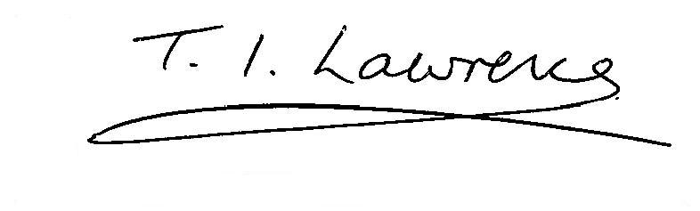

IAN LAWRENCE
General Secretary

