4 Chivalry Road, London, SW11 1HT
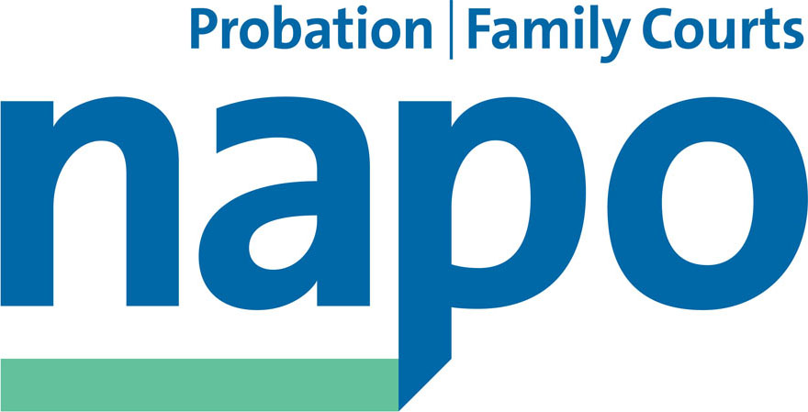

Telephone 020 7223 4887
Fax 020 7223 3503

www.napo.org.uk
Email: info@napo.org.uk

IL/AV 29-16

Colin Allars, Director, National Probation Service

(By e-mail)

9th March 2016

Dear Colin,

Job Evaluation and the E3 programme =Conflicting advice from NOMS on the appeals process

As you are aware, Napo, along with our sister trade unions have been in regular engagement with your Senior Management colleagues in NOMS about the intended direction of travel on the wider E3 programme which is meant to be informed by the current Job Evaluation (JE) exercise. My understanding is that the JE scheme is expected to be conducted in accordance with the agreed NNC process which allows for individual appeals and a route for requesting reviews of outcomes.

The probation unions have already expressed our rejection of the recently published results for the AP Area Managers, AP Managers, AP Residential workers and the VLO roles respectively and, as you would expect, we have been inundated with requests for assistance from members wishing to appeal and have issued preliminary advice on the appeals process based on the above NNC agreement.

The trade unions will be urgently discussing our collective approach to these JE outcomes and will make the necessary representations, but the purpose of this letter is firstly to request that the JE issue is included on the agenda for tomorrow’s meeting of the National Negotiating Council and prioritised for early discussion. Secondly, I have to express my serious disappointment at the advice which I am informed has been issued by NOMS to the effect that Divisional Directors are to soon be contacted about the possibility of a collective appeals process.

Given that the unions were advised at last week’s Engagement Meeting that there was no scope for such a remedy, I hope you will appreciate that the problems around the JE outcomes have now been exacerbated by a failure to advise the unions of your intentions which are directly contrary to our understanding.

Without wishing to pre-empt the wider discussion that we need to have at the NNC, I believe it is vital that an immediate halt is announced to the JE implementation programme and the 20 day appeal period until we have agreed a solution to this worrying situation.

I am, as always, available for a telephone discussion on the above if you are available today.

Yours sincerely,

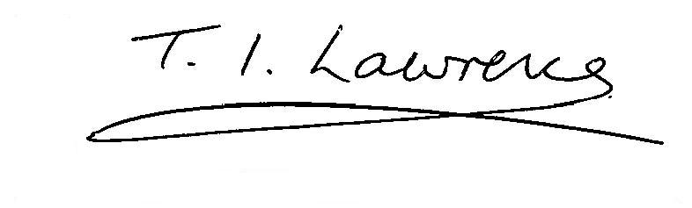
IAN LAWRENCE
General Secretary

Cc: Michael Spurr, Jim Barton,
Jude Gray, Francis Stuart, Nick Jones

