160 Falcon Road, London, SW11 2NY
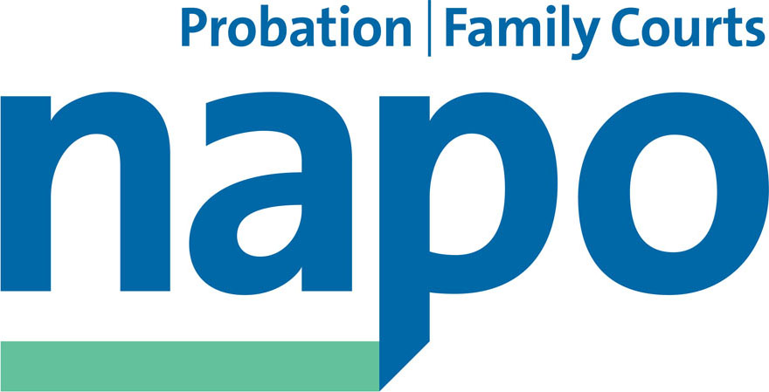

Telephone 020 7223 4887
Fax 020 7223 3503

www.napo.org.uk
Email: info@napo.org.uk

IL/AV 43-17

7 April 2017

To CEOs CRCs and RISE

Dear

Napo Pay Claim 2017-18, Implementing Pay Reform and Addressing Pension Miscalculations

We are pleased to attach our 2017 National Pay Claim. You will see this is a comprehensive document that outlines what Napo see as the ingrained structural faults undermining all aspects of probation pay and the need to align consistent, well-funded pay reform with a wider, and long overdue Professionalising Probation agenda.

As you will be aware Napo has been engaged with the NPS for some months in a Pay Review that formed part of the 2014-15 probation wide pay settlement. Since the demise of the NNC these talks now only cover the NPS. The claim is consistent with the ideas emerging from these ongoing negotiations and Napo remain positive and hopeful that these talks will achieve significant steps towards addressing the structural weaknesses that are set out in the claim.

However, we are also acutely aware that the problems inherent in the probation pay system equally apply to the employees in the CRC's (RISE) and that the employer is as vulnerable to suffering the consequences of continued failure to address these weaknesses as the NPS, and arguably more so. Changes to softer terms and conditions, such as improved maternity pay, recently negotiated with the NPS (particularly to support closer working with prison staff as part of the new HMPPS and also to address consistent HR processing problems with their shared service centre model) are currently being considered by our NPS members which in turn will increase pressure upon yourselves to match these, even before we consider basic pay.

Napo recognise that the pressures upon the CRC contracts mean that asking you to match the softer changes and potential pay increases set out in the claim could seem unreasonable. However, we also recognise that a failure to do just that will make you uncompetitive to staff and have a seriously damaging impact on efforts to recruit and retain the experienced, skilled workforce that you need to meet the contractual expectations of the MoJ and HMIP.

Accordingly, Napo invite you to urgently discuss with us how a joint case can be submitted to the MoJ and HM Treasury, as part of the on-going Probation Services Review, to ensure there is the necessary contractual pricing support to give you the capacity to compete in the pay market place they’ve created.

We would also invite you to meet with ourselves, local Napo Representatives and your HR leads to discuss the background issues in the claim and the softer harmonisation changes that are under consultation ahead of any formal pay talks, so that when we are in a position to negotiate constructively with you, we are well placed to move forward quickly.

In addition, we would also want to specifically brief you about the on-going pension errors that apply to the 2014-15 and 2015-16 pay awards and which apply to any employees who have left mid-year. We are aware that the NPS failed to alert you to the obligations under the scheme in this regard and as such you will have incurred the same liabilities that they have accepted apply to them. Napo’s initial view is, as set out in the claim (although it is one step removed from future pay awards) that any costs to yourselves should be met by the Secretary of State’s indemnities clause in the ARSA and we would support you in arguing this to the MoJ. However, in doing so we would expect you to work with us to begin rectifying the errors as soon as possible.

Napo looks forward to your consideration of the above and the attached pay claim and to receiving your initial response. If you have any questions or concerns please contact the Napo National Link Official who you may also wish to copy in to your reply.

Yours sincerely

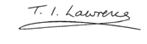
IAN LAWRENCE
General Secretary

