4 Chivalry Road, London, SW11 1HT
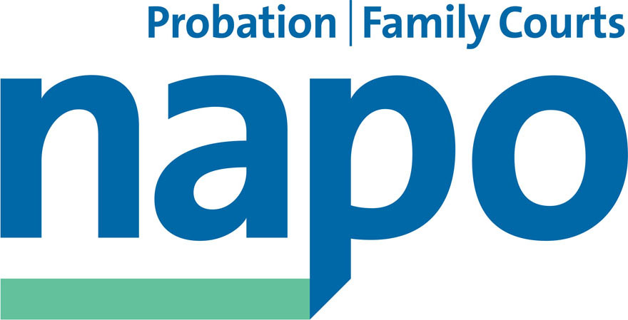

Telephone 020 7223 4887
Fax 020 7223 3503

www.napo.org.uk
Email: info@napo.org.uk

IL/AV 46-2014

9th April 2014

Via email:

Amy Rees, Deputy Director Rehabilitation Programme

Dear Amy,

Next TRCF meeting - 10th April 2014

Given the time limitations and the agenda items to be discussed I would appreciate the following statement from Napo being recorded into the minutes for tomorrow please.

‘Ever since the announcement of the Secretary of States so called Transforming Rehabilitation agenda, Napo and the probation unions have warned that this change programme is operationally flawed and represents a real risk to community safety.

Since recently launching a specific conduit for our members to notify of us of their concerns following the imposed staff assignment process, Napo has been inundated with hundreds of examples which indicate that our predictions have unfortunately been vindicated.

Napo will now be seeking to publicise a range of public interest issues concerning:

The cost of consultants and the hidden costs of the overall TR programme

The risk of harm to staff and members of the public which is directly attributable to an unfair and un-agreed staff assignment process

A failure by Ministers and their Officials to adhere to the Public Equality duty

Potential discrimination cases for failing to make sufficient provision in the areas of disability, maternity and provision for part time workers.

Potential breaches of employment law in terms of fair and open competition for vacancies, the arbitrary ‘ring fencing’ of posts and potential conflicts of interest involving senior managers undertaking a dual role within two organisations

The emotional breakdown and high sickness rates being suffered by many staff who have been left in total chaos by the inept and unnecessary rush to split the probation service into two separate strands in advance of the intended ‘go live’ date.

Staff being induced to ‘sell’ their annual leave to mask serious operational deficiencies

Inappropriate allocation of cases in breach of the original EOI guidance issued by the Trust

Withdrawal of SDR facilities to Magistrates Courts and reductions in Court Reports due to increased case handling times and staff shortages

Non allocation of cases due to ICT difficulties (NDelius)

Estates relocations causing difficult journeys for clients which will probably result in appointments not being kept

You may already be aware that Napo has registered its concern at the proposals within the Target Operating Model in relation to Probation Staff in Prisons.

The above list is by no means exhaustive, but Napo wishes to formally record its serious concern at the grave operational situation. Even at this late stage we call on Ministers to halt the programme or at the very least extend the lead in time to the creation of the NPS and CRC environment.’

Yours sincerely,

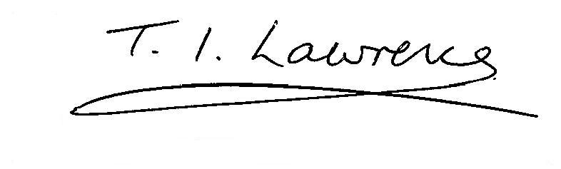

IAN LAWRENCE
General Secretary

CC Matt Grey
Judy Webb
Ben Priestley
David Walton

