4 Chivalry Road, London, SW11 1HT
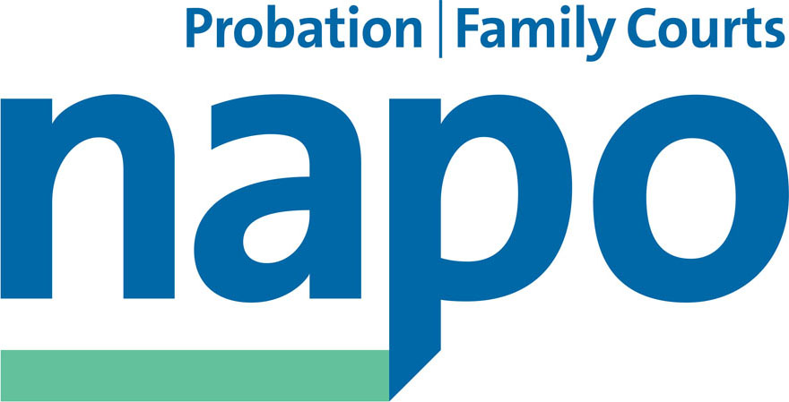

Telephone 020 7223 4887
Fax 020 7223 3503

www.napo.org.uk
Email: info@napo.org.uk

IL/AV 48-14

11 April 2014

Via email:

Sir Hugh Orde, President
Association of Chief Police Officers
1st Floor, 10 Victoria Street
London
SW1H 0NN

Dear Sir Orde,

The Future of Integrated Offender Management within "Transforming Rehabilitation"

On behalf of our members working in front line probation work, we are writing to outline our serious concerns about the immediate risks facing Integrated Offender Management.

Perhaps before we detail the exact nature of these, we want to express Napo's full support of the existing IOM partnership arrangements in many local communities. We are sure that you, along with many of your dedicated police staff, are similarly supportive of IOM. Integrated Offender Management is an exemplar in multi-agency approaches to reducing re-offending. Led by Police and Probation, with partnerships within criminal justice and non-criminal justice agencies, social enterprises and the not for profit sector, IOM has achieved excellent results in reducing crime.

To give a few illustrative examples, a recent London Councils Report dated found that in the London Borough of Islington, IOM had reduced re-offending by 52.3%. A cost benefit analysis by Sheffield Hallam University conducted over the period 2012/13 in Surrey and Sussex, calculated that IOM, balanced against the costs of offending, saved the tax payer £1.59 for every £1 spent over 5 years. Over 10 years, the saving was £1.79.

The Home Office literature dated 26 March 2013 cites the following key principles and benefits:

- Joint work between local partners encouraging the development of a multi-agency problem-solving approach by focussing on offenders, not offences.
- All offenders at high risk of harm and/or re-offending are "in scope".
- Intensity of risk management relates directly to the severity of risk, irrespective of position within the criminal justice system or whether statutory or non-statutory.

Under Transforming Rehabilitation, the government will abolish all Probation Trusts on 1 June 2014 and create two new, untried organisations. The National Probation Service (NPS) will manage court work, high risk of harm offenders and victims. The NPS will be organised over 7 regions in England and Wales. 21 Community Rehabilitation Companies (CRC) will be created which are neither co-terminus with police forces, local authorities nor counties. These organisations will manage low and medium risk of harm offenders. The Secretary of State for Justice proposes that these CRCs will be tendered out to preferred bidders. The existing public sector Trusts are barred from entering the competition.

The split of the Probation Service is having a deleterious impact on IOM. IOM staff in Probation have been assigned to CRCs. As the CRC will not manage the high risk of harm IOM cases, the Home Office guidelines about offenders “in scope” has now been compromised as those cases move into different NPS regional divisions.

The Ministry of Justice has stated that the IOM will continue in the CRC if the new provider wishes it so. Their argument is that the success of the IOM will ensure that private providers maintain provision. However, there is no obligation on them to do so. We are concerned that under a “payment by results” model, there will be a tension between the CRC and other agencies about who is deserving of the payment. In other words, the existing co-operative arrangements will be reduced to commercial transactions as the privately owned CRC will be able to profit from the work of the other agencies. This is a new, and in our view potentially risky, arrangement. IOM is rightly resource intensive but we envisage that financial pressure will bear upon models of good practice despite the evidence of savings being achieved in the longer term.

Between 1 June 2014 and, an as yet unspecified time in Autumn 2014, the CRC will remain in public ownership and it may be possible, albeit difficult, for agencies to continue IOM work. This will change dramatically when the shares in the CRC are sold and private contractors take over. Existing successful partnerships are based on relationships which have evolved over time but which we believe will be fractured in the new arrangements. New Service Level Agreements and Memorandums of Understanding will have to be formed. In the interim, this poses a new and unnecessary risk in terms of a lack of information exchange. There are already Data Protection Act problems in the sharing of information between the public and private sectors which will hinder effective risk management.

Our members are regularly reporting concerns shared between IOM practitioners from all sectors about the impending changes. We felt it was right to bring this to your attention and would welcome an early opportunity to meet with you to discuss these issues with you and hopefully enable a joint approach.

We look forward to your reply.

Yours sincerely,
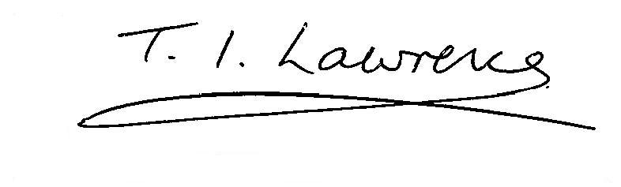
IAN LAWRENCE TOM RENDON
General Secretary Chair

