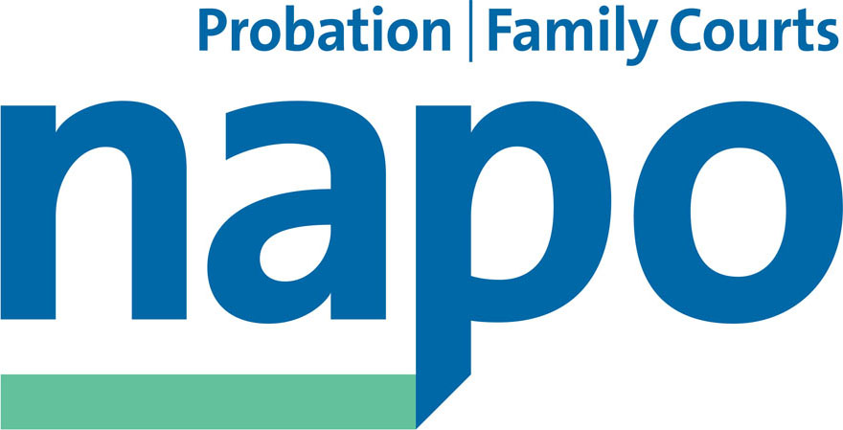



JTU 12-15
10th June 2015

Position Statement

At today’s meeting between Sodexo, Napo, Unison and GMB the trade unions discussed the proposal from Sodexo to vary the terms for Enhanced Voluntary Redundancy (EVR) which is part of the company's plans to implement a staff reduction programme.

The trade unions have made it clear that this offer is unacceptable and that we expect the CRCs under Sodexo's ownership to fully abide by the terms of the National Staff Transfer Agreement. The unions will now be urgently consulting with their representatives employed within the Sodexo owned Community Rehabilitation Companies.

Additionally, and given the complexities of the issues under discussion the trade unions will be referring the situation to the National Negotiating Council and NNC SCCOG for urgent attention.

Until such time as these issues are resolved the trade unions believe that the current pause on the staff reduction plans should continue.

Ian Lawrence Ben Priestley David Walton
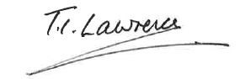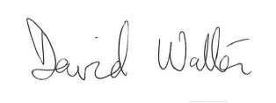
General Secretary National Officer National Secretary
Napo UNISON GMB/SCOOP

