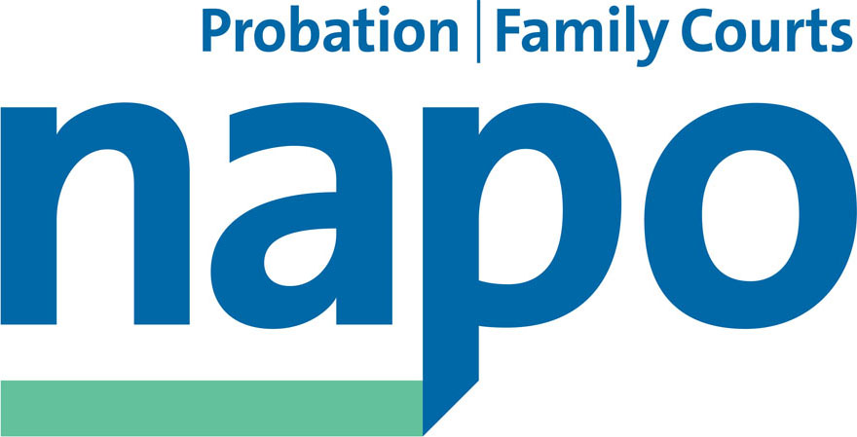



JTU 17-15
HARBHAJAN SINGH BRAR
HR Director
Sodexo Justice Services & Central Functions
Sodexo
One Southampton Row
London WC1B 5HA

(By e-mail)

15 July 2015

Dear Harbhajan,

SODEXO JOB CUTS AND EVR

You previously asked the unions to respond to you on the above by 15th July.

We are now in receipt of an invitation from you via the NNC Joint Secretaries to meet next Monday prior to the presentation of the intended Target Operating Model that we understand is the driver for the substantial staff reduction programme that you intend to announce tomorrow across the six Sodexo owned CRCs. We acknowledge that your communication will make it clear that this does not preclude further discussion with the trade unions.

Now that we have at last been able to establish (by way of the recent Joint Secretaries determinations) that formal discussions about these issues can only take place within the established national collective bargaining arrangements, we confirm our attendance on Monday. We expect to be able to provide feedback from the joint meeting of Napo/UNISON and GMB representatives taking place this Friday.

Issues at large

You are already aware from our informal discussions, that the probation unions believe that the content of your proposal to offer a variation of the Enhanced Voluntary Redundancy scheme (EVR) is outside of the formula previously underwritten by the Secretary of State and enshrined in the National Agreement on Staff Transfer and Protections (NASTP) and published prior to share sale. It is one that we are not prepared to accept on behalf of our members, until we have been party to substantive and centrally conducted negotiations under the auspices of the NNC and SCCOG, and have had an opportunity to consult with our constituent members.

The unions find the thinly veiled threat to withdraw the EVR scheme (or alternatively that Sodexo will decide to move to compulsory redundancies in September) to be serious acts of bad faith, which would irreparably damage industrial relations between us and which may have consequences in terms of us seeking the views of our wider membership beyond those situated within the Sodexo owned CRCs.

We must also reject the notion that that the delay in releasing information to staff is the fault of the trade unions, especially given the fact that the intention to make 600 job cuts across your contract package areas was announced last Easter without any notice to us whatsoever, and that the presentation of the Target Operating Model which will obviously impact on our wider views about your plans is only taking place next week.

Our approach up to now has been to urge the company to recognise that negotiations on national terms and conditions have to take place on a national basis. We appreciate that you believe this is a hindrance to the business, but we also face problems that we have to live with, namely the outsourcing of thousands of our member’s jobs across the probation service and the potential impact on their terms and conditions and their future employment status.

You should also know that these issues, and the company’s refusal to honour the full terms of EVR, took up the best part of our meeting with Michael Gove the Secretary of State for Justice yesterday. We have also furnished him with copies of the documentation that has featured in the previous discussions between us concerning the NASTP and your interpretation of the obligations under the contract between yourselves and the Secretary of State. We have also advised you that the trade unions request for access to the commercial contract was denied to us despite numerous FoI Act requests. This would have at least afforded us an earlier opportunity to discuss this clear gap in our respective understanding.

Unanswered questions

Despite our request to have some prior indication of the information that you intend to issue to staff within the six CRC’s under your ownership, you have decided to present the job cuts position and intended EVR scheme tomorrow. We have previously explained that we do not have the mandate to accept these terms which in our view jeopardise the above national agreement. Moreover, we have consistently stated that we do not believe that your intended staff reduction programme is justified and that we have serious concerns about its potential impact on public safety.

Meanwhile, as an indication of the complex landscape that we are in, here is a summary of some of the most regularly asked questions that have reached us from members within the last few days. Whilst you consider how you might wish to respond to them, we hope you will agree that the subject matter demonstrates how it imperative it is that that urgent negotiations should take place with the unions where these and other key pieces of information can be discussed with a view to reaching an agreement.

- Why are Sodexo saying they don't have to comply with the National Agreement - i.e. 4.5 weeks’ pay per years served?

- What is the MoJ doing about this? Might they cover any shortfall in EVR payments?

- How are the government holding Sodexo to account?

- Why can't members know which posts are at risk before they contemplate applying for EVR

- How will I find out if my post is at risk?

- What will the advice to members be when the consultation starts on what discussion they should enter into about their personal VR package?

- What is going on with estates? Why have my CRC not yet identified buildings to support the proposed Target Operating Model and should my future location not be a major factor in making a decision on whether or not to apply for an EVR?

- Why has the ‘hub’ building contract not been signed yet? *(This has caused members to speculate that Sodexo are delaying as they might pull out of the CRC contract)

- Will all this delay mean that they'll just make us compulsorily redundant? Are they delaying on purpose to get us closer to the September date?

- Why are Sodexo being allowed to dictate the time we are allowed to respond/consult with members?

- What is the current position in regards to TUPE and the proposed shared service centre transfers? Should I not know all the facts about the potential EVR package before I accept or reject an offer to relocate to Salford?

- What is happening with the IT bridging solution? Has it totally fallen apart? Will this change things?

- Is it true that Sodexo are refusing to pay full EVR but at the same time are asking for more money from the MoJ over IT failures?

- I have seen a job advert posted by a Sodexo CRC at £25 per hour when there are redundancies being announced. What’s going on?

- I'm aged over 55, (or fast approaching 55), are Sodexo entirely clear as to the terms of the release of pension deal they are offering, and how long for?"

In the interest of transparency we are copying this letter to the NNC Employers’ side Joint Secretary, all Chief Executives in the Sodexo owned CRCs and making it available to our respective members.

We look forward to your reply and our meetings next week.

Yours sincerely,


IAN LAWRENCE BEN PRIESTLEY DAVID WALTON
General Secretary National Officer National Secretary
Napo UNISON GMB/SCOOP

CC: Francis Stuart, Employers Side Secretary NNC
Chief Executives, Sodexo owned CRCs
Rt Hon Michael Gove MP, Lord Chancellor and Secretary of State for Justice
Rt Hon Andrew Selous MP, Parliamentary Under Secretary of State for Prisons, Probation, Rehabilitation and Sentencing

