JTU 22/2024
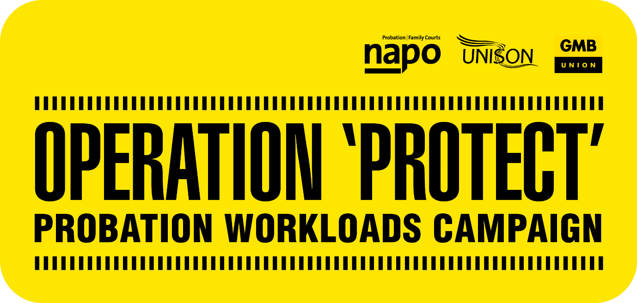

20th March 2024
PROBATION WORKLOADS CRISIS
WRITE TO YOUR MP
Napo, UNISON and GMB/SCOOP are encouraging members to write to their MP about the current workload crisis in probation and the effect that this is having on services, staff, and communities. Enclosed with this bulletin is a model letter for this purpose.
Recently Amy Rees was asked questions by the Justice Select Committee about Probation workloads which had been influenced by engagement with Napo, UNISON and GMB/SCOOP.
Alongside this there are ongoing talks with the employer about taking meaningful steps to reduce workloads.
We’re aware that, despite these efforts, workloads are increasing in an unplanned and chaotic way due to the extension of the End of Custody Supervised Licence (ECSL) scheme and the introduction of Fixed Term Recalls for those serving under 12 months.
That’s why we’re now asking members to contact their MP to raise the issues caused by excessive workloads.
To find your MP’s email address visit here: https://members.parliament.uk/members/Commons, if you don’t know your MP you can use your postcode to find their details here. Using the enclosed model letter, remember to:
- Send the letter from your home email address, or via post. Please do not send from you work e-mail account.
- Add your home address at the top of your letter as your MP will only respond if they know you live in their constituency.
- You can add your personal experience of the impact of excessive workloads.
- Add the contact details of your union, if you would like your MP to speak to us for further information:
GMB/Scoop: Peter.Brandt@justice.gov.uk
Napo: Info@napo.org.uk
UNISON: b.priestley@unison.co.uk
- Alternatively, you can request to meet your MP and we’d love to hear how those meetings go.

Please also send a copy of the letter you send to your union.

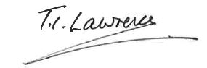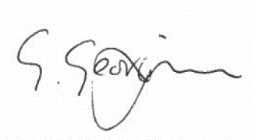

Ian Lawrence Ben Priestley George Georgiou
General Secretary National Officer National Officer
Napo UNISON GMB/SCOOOP

