JTU 25/2025
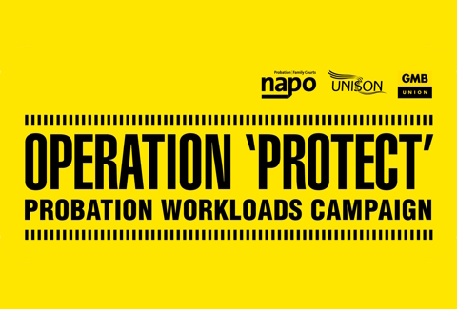
1st May 2025
Operation Protect – Bulletin 3 2025
Lack of HMPPS Action
The trade unions are issuing this update on the progress, or rather lack of progress, on the work we have been doing with HMPPS representatives on the issue of excessive workloads in the Probation Service. Despite the positive narrative promoted by the employer it remains our view that its efforts are poorly thought-out, misguided and will do little to meaningfully deliver workload relief. The employer has refused to progress the range of wider workload relief strategies that we had developed and presented to them in two sets of proposals, offering contradictory and confused responses when challenged by us on their position. The trade unions have been clear its proposals have been developed and endorsed by practitioners and are specifically designed to bring the greatest amount of workload relief to the widest range of staff in the Probation Service.

Our Future Probation Service Concerns
While HMPPS promote the Our Future Probation Service (OFPS) programme as the vehicle to reduce workloads it is apparent this is a poorly considered project that repeats the series of failures that have been inflicted on our members in recent years, such as the ‘One HMPPS’ programme. Given the lack of transparency involved it remains difficult for the trade unions to determine how OFPS operates, or how it considers and progresses its plans, but the results so far are either incredibly underwhelming or of significant concern and give us no confidence in its ability to deliver for staff at this point.

The trade unions have offered constructive criticism of the employer’s plans that have come from the OFPS programme. We have also been clear where we have not believed HMPPS should proceed with specific plans in any form, especially where these threaten Probation professionalism. One such plan was ‘Impact’ which we believe is a fundamentally dishonest, threatens whatever remains of our credibility – primarily with the Courts – and repeats the numerous flaws of last year’s ‘Probation Reset’. The trade unions have also called for senior HMPPS leaders to be held accountable where their previous decisions, against the representations of the trade unions at the time, have led directly to the basic failure of the Probation Service to deliver core functions. An example of this is Programme Prioritisation, where operational decisions taken years ago by HMPPS have effectively destroyed the ability of the Probation Service to deliver accredited programmes to those required to complete them, creating significant additional workload for others, for those in Sentence Management and the Courts.

The trade unions continue to put pressure on HMPPS to be honest with staff and present them with the embargoed information on the depths of the staffing crisis in the Sentence Management Probation Service. We do not believe the employer has any justification for their continued delay – now at almost two months – to prevent its release and our position is that the data must be released immediately, followed quickly by those they have yet to disclose to us, for example on Court work. To be clear, this is not some abstract issue, and this information is of direct relevance to thousands of staff in the workforce. HMPPS have consistently refused to properly acknowledge the scale of the additional workload placed on Probation staff in recent years, such as from various schemes to reduce Prison overcrowding.

Next Steps
It's clear to us that, despite our best efforts, our attempts to work with this employer in delivering workload relief for our members have been unsuccessful to this point, and there seems to be a low likelihood that this will change. We now need to urgently consider as individual trade unions what approach our members want us to take, before meeting again as soon as possible to consider the potential for joint action. We are extremely frustrated and disappointed that HMPPS have responded so poorly to our efforts put in place meaningful change to reduce workload across the Probation Service, and to be honest with staff about the scale of the problem, but remain committed to act for our members.

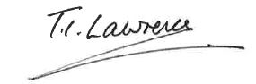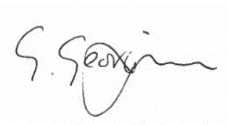

Ian Lawrence Ben Priestley George Georgiou
General Secretary National Officer National Officer
Napo UNISON GMB/SCOOOP

