**JTU 30/2025**

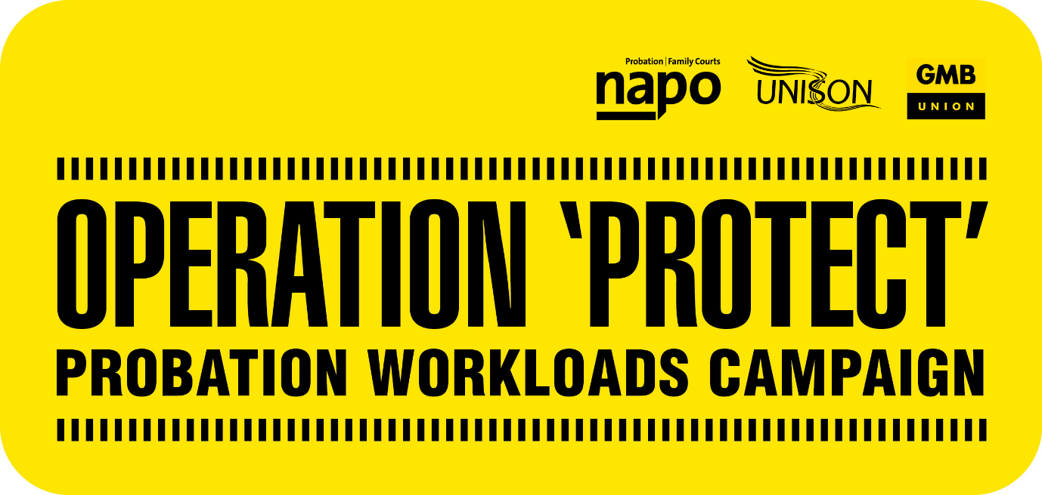

**UNION RALLY – WEDNESDAY 11 JUNE**

**SADLER’S YARD, MANCHESTER**

Napo, UNISON and GMB/SCOOP Probation members are invited to support an Operation Protect and Pay Campaign rally being held at lunchtime on Wednesday 11 June at Sadler’s Yard, Manchester, next to the Redfern Building.

Please come along to show your support for the unions’ joint campaign against excessive probation workloads and our campaign for a fair 2025 Probation pay award to get more money in members’ pockets.

Featuring speakers from the probation unions, start gathering from **12 noon a 12.30pm start to be finished by 1.30pm** with photos at the end. Members should attend in their own time.

Remember to wear something Yellow!

**END EXCESSIVE WORKLOADS!**

**RESTORE PROBATION PAY!**