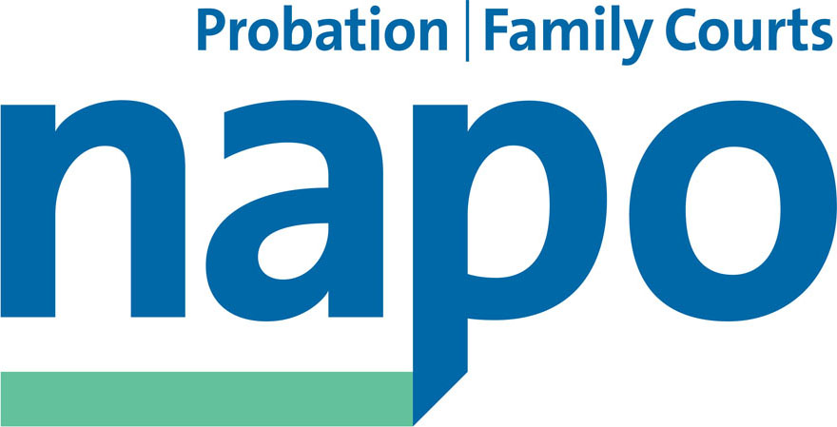



JTU 16-17

Lord Michael Bichard KCB, Chairman
National Audit Office
157-197 Buckingham Palace Road
Victoria
London SW1W 9SP
9 August 2017

Dear Lord Bichard,
Transforming Rehabilitation: announcement of additional tax-payer spending
We are writing as the three recognised trade unions in the National Probation Service (NPS) and the 21 Community Rehabilitation Companies (CRCs). We wish to draw your Committee’s attention to our concerns about the recent announcement by the Secretary of State for Justice of new spending on the MOJ’s Community Rehabilitation Company contracts.

When you published your report into the government’s Transforming Rehabilitation Reforms in April 2016 you concluded by saying:

‘While NOMS’ oversight of CRCs is robust, significantly lower levels of business than the Ministry projected will affect some CRCs’ ability to deliver the level of innovation they proposed in their bids. Furthermore, the NPS is not yet operating as a truly national, sustainable service. Achieving value for money from the new probation system will require resolving these fundamental issues, and ensuring the right incentives for all participants in the system.’

You also indicated in the report that:

‘The Ministry put prudent protections in place to help mitigate the risks to the taxpayer and to critical services where providers seriously underperform or fail outright.’

Whatever promises the MOJ made to your Committee last year in relation to its ‘prudent protections’, on the last day of Parliament on 19 July, the Justice Secretary issued a low key statement to staff in the NPS and the CRCs to the effect that the government had bailed out the failing CRC contracts with an unspecified amount.

In his written ministerial statement of the same date, Sam Gyimah, the Prisons and Probation Minister, referred confusingly to ‘...additional investment...’ in the contracts, but cryptically placed a caveat over the issue by stating that this additional money will see ‘...projected payments to CRCs still being no higher than originally budgeted for at the time of the reforms...’ Given the implications for the public purse of these apparently contradictory statements and the seeming lack of scrutiny that has occurred we consider the matter should be investigated by your committee the NAO in order to ensure taxpayers’ money has been well used and parliament has not been circumvented.

We are not alone in our criticism of the timing of these two announcements, nor are we alone in extolling the view that the government is so ideologically committed to probation privatisation that it will do all it can to hide that it has failed at the expense of the taxpayer.

We are also concerned as to why the Secretary of State has not yet answered why he had not published the outcome of his department’s Probation System Review which was initiated, at least in part, to ‘...address the observations and recommendations within the National Audit Office report on TR.’

We have written to the Secretary of State to ask him why the Probation System Review findings were not made public and to ask him to explain exactly what he meant when he told staff that he had ‘...adjusted the CRCs’ contracts to reflect more accurately the cost of providing critical front line services..’ We did so as we are very keen, and we consider you ought to be, to find out whether additional tax-payers money has been given to the CRCs over and above what they are entitled to under their contracts. There seems to be no transparency on this which is obviously totally unacceptable.

We enclose a copy of our letter to the Justice Secretary and would be grateful if you could bring this correspondence to the attention of your Committee with a view to the Committee calling in the MOJ to account for the justification for the apparent additional spend on the failing private probation contracts.

Yours sincerely,
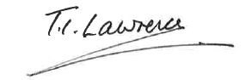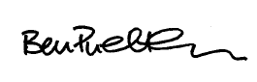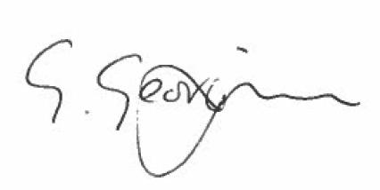
Ian Lawrence Ben Priestley George Georgiou
General Secretary National Officer National Officer
Napo UNISON GMB/SCOOP

CC Oliver Lodge, Director Justice VFM

