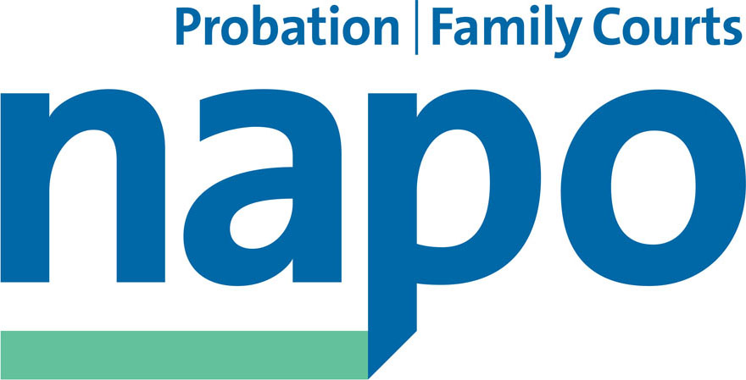


JTU 24-17

Rt Hon David Lidington MP
Secretary of State for Justice
Ministry of Justice
102 Petty France
London SW1H 9AJ

27th September 2017

Dear David,

Failure of National Probation Service/SSCL to Pay NPS Staff and Pensions
We are writing to you to put on record our concern as the recognised trade unions for staff working for the National Probation Service over the catalogue of errors caused by NPS/SSCL in relation to our members’ pay and pensions.
In this letter we set out the sorry catalogue of errors/problems, which we assume has already been brought to your attention. The most recent pay errors have been the result, so we have been told, of the failure of SSCL and its sub-contractor to copy over pay and pensions instructions in the migration from the previous Phoenix pay system to the new SOP system.
However, as we set out later in the letter, NPS has been unable to reassure that the latest pay errors were not also in evidence under the previous Phoenix system. We have evidence of pay and pensions maladministration pre-dating the SOP migration, which have probably been in existence since the inception of NPS on 1 June 2014.
The inability of your department to pay its staff properly is a matter which the unions take extremely seriously, as we hope you do likewise. We were informed at a meeting with NPS ,and the MOJ contract manager for the SSCL contract, that the contract price paid to SSCL required the government to retain liability for any mistakes made by the contractor. As a result, we have been told that our members will have to bear liability for the contractor’s mistakes. We are sure that you will recognise the inequity of such a position and we seek your intervention to resolve this in our members’ favour.
- SSCL issues inaccurate P60s
HMPPS NPS News No. 93 August 2017 confirmed to NPS staff that:
‘HMPPS is aware that for members of the LGPS (Local Government Pension Scheme) there are issues with the accuracy of the 2016/17 P60 you have been sent or viewed online. The issues are related to the calculation and recording of pensionable pay elements. We have been working with SSCL to investigate the problem, resolve these issues and to ensure the correct information is provided to HMRC and GMPF.

We recognise this is an important matter to all staff in the LGPS and we will provide regular updates until this matter is resolved. At this time, staff are not required to take any action, and we would ask you to please refrain from sending emails so that resource is not diverted from resolving the issues.

We are also aware that Annual Pension Benefit statements will be issued shortly and these will be reviewed once the known issues with the calculation and recording of pensionable pay elements have been resolved.’
Staff have been told that this was a printing error and that the mistake will not affect tax, but as the following error indicates, staff will have little faith in such reassurances.
- SSCL fails to collect or pay Local Government Pension Scheme contributions in respect of premium payments to the Greater Manchester Pension Fund
Following contact from members, who believed that the employer was not deducting pension contributions in respect of some elements of pay, UNISON wrote to the NPS to ask for an investigation. The NPS Director of Probation confirmed to UNISON on 3 August 2017 that:
‘I am aware that HMPPS failed to collect and pass on to the pension fund, employee pension contributions in respect of the NNC Unsocial Hours Allowances (30% & 50%) from February to June 2017 inclusive. I appreciate that this is a frustrating error, and I understand this has been brought to your attention on numerous occasions by your members. I want to apologise for this happening and want to assure you that as soon as this error was realised it was corrected as a priority.

As ....explained to you this was a failure on the part of a sub-contractor of SSCL to correctly migrate the collection arrangements for these two allowances in the move from Phoenix to SOP. As a result of this our employees claiming this allowance did not have correct pension contributions deducted for a period of 5 months. As.... has told you, this has now been corrected, and pension deductions will be processed and paid to the pension fund in the July payroll.’
As the failure to pay over the pension contributions exceeded 90 days, the Greater Manchester Pension Fund is required to notify the Pensions Regulator of this serious failure in pension administration. Given the admission of fault on the part of the private contractor, UNISON has asked NPS to cover the cost of the pension contribution arrears.
- SSCL fails to collect pension contributions from staff on maternity leave
Following enquiries by Napo on behalf of their members on maternity leave, NPS confirmed on 9 August 2017:
‘Thank you for your email of 4 August relating to an error with the deduction of pension contributions for those on maternity leave, and for bringing this issue to our attention. We can only apologise for this error and for any stress and/or inconvenience this has caused your members.
We have contacted Shared Services Connect Limited (SSCL) who have confirmed that the error was created due to a “background software” issue with the Single Operating Platform (SOP), and they have instructed the software providers to urgently look into this issue and provide a solution to re-configure the system correctly.
At the moment SSCL are interrogating the payroll to ensure they capture all employees who may have been affected by this software error and we will be individually contacting them in writing to confirm the situation and how this is to be resolved.
We have also contacted Emma Mayall in GMPF with regards to the issue with the error in deducting contributions being potentially identified as a break in service and not as continuous service. We have asked them not to take any action at this point with regards to the pension records for those they have identified, so we can bring this issue to a satisfactory conclusion.
We will keep you updated throughout the process of identifying all of those affected, and will contact you on the next steps in resolving this issue once the interrogation of the payroll is complete. HMPPS is aware of the disruption that this may result in and wish to express our sincere apologies to employees for any inconvenience this may cause. We would ask that you work with us to alleviate staff concerns and reassure them that we are working to resolve all issues as soon as possible to minimise any distress that may be caused.’
- SSCL fails to collect pension payments from staff on sick leave
NPS also confirmed on 25 August that staff in receipt of occupational sick pay had not had their pension contributions collected by SSCL.

In September, NPS confirmed in relation to points 2, 3 and 4 above that: ‘Those affected by the pensionable pay elements on SOP have been identified (SSCL have identified 1,582 individual cases) and will be contacted in writing in due course, providing them with details of the error that has occurred to their pension record, how this will be corrected and how the underpayment of contributions will be made to the pension scheme.

The correction to the underpayment of pension contributions could impact on an individual’s tax record, as pension contributions are calculated before the calculation and deduction of tax. Individuals may need to contact HMRC personally to sort out any issues, once their tax record has been corrected.’
- Publication of inaccurate Annual Pension Statements to NPS Staff
NPS reported at the end of August that, ‘Annual Pension Benefit Statements have been printed and will be sent out to staff to meet the 31 August deadline. Unfortunately, due to the reporting of pensionable pay elements to GMPF (Greater Manchester Pension Fund) these are incorrect, and due to the process of production and posting of benefit statements in GMPF these will be dispatched.’
- Failure to auto-enrol NPS staff in the Local Government Pension Scheme
For the five months following the introduction of SOP the NPS failed to auto-enrol new starters in the Local Government Pension Scheme.

- Pay and Pensions Errors Pre-SOP, unrelated to SOP
As set out in the introduction to this letter, NPS has been unable to confirm that the problems which have been identified as a result of the botched migration of the NPS payroll to SOP were not already impacting on staff prior to the migration. NPS has indicated that it will need to work with SSCL to audit individual salary statements before it can provide any such assurances. Any such problems identified are likely to go back three years to the start of NPS on 1 June 2014.
However, we can confirm that the following were pre-existing pay problems prior to the SOP migration:
- Pension contributions not collected for sessional hours of work undertaken by NPS approved premises staff
- Pay protection payments for approved premises staff not paid, or paid incorrectly
- Late payment of contractual increments in 2014, 2015 and 2016 by NPS leading to failure of these increments being applied to unsocial hours payments and additional hours payments going back over three years
- Pension contributions on the outstanding three years of incremental pay rises on unsocial hours not collected
These examples are just a selection of the pay problems which are only gradually emerging as a result of the diligence of our members who have had to work out themselves that their employer is not paying them correctly.
- Prohibition on NPS staff raising grievances over pay errors
The NPS has confirmed that:
‘As an employment relationship does not exist between SSCL and our employees it is inappropriate for an employee to raise a grievance, to NPS, regarding the service received from our HR Supplier SSCL. Neither can an employee raise a grievance directly with SSCL, as SSCL are acting on behalf of HMPPS. It is more appropriate that the employee raises a complaint should they feel the service received from SSCL, was not up to standard.’

This Catch 22 situation effectively prevents employees from seeking resolution of pay problems via the normal channels open to most employees, and which are required in respect of any subsequent claims to an Employment Tribunal.

The fact that NPS has outsourced its payroll provision does not absolve NPS of its responsibility as an employer to comply with the ACAS ‘Code of Practice on Disciplinary and Grievance Procedures’. Many employers have their payroll administered by outside organisations (many former Probation Trusts for example contracted their payroll to their local authority), but this does not prevent the staff in these organisations from raising grievances over pay with their legal employer. The NPS actions here seek to frustrate access to justice for staff via Employment Tribunals, which is extremely troubling for a directorate of the Ministry responsible for the Tribunal Service.

We draw these issues to your attention as they point to a near total breakdown in the ability of your Department to pay its staff correctly, or administer their pensions in line with regulations. Due to the maladministration of the pension deductions for the five month period earlier this year, the Greater Manchester Pension Fund is bound by law to refer the National Probation Service to the Pensions Regulator. The Regulator is able to fine an employer for failure to follow pension regulations.

Napo and UNISON have asked the National Probation Service to take responsibility for settling both the employee and employer pension arrears in relation to the failure to deduct pension contributions, but so far it has been unable to respond positively to this request. The potential size of arrears is apparently a factor which is limiting its ability to take responsibility in this respect.

We therefore ask you to:
- take personal responsibility for the above failings and to instruct NPS to shoulder the cost of paying both the employee and employer arrears in respect of pension contributions which have not been collected.
- take responsibility for correcting any adverse tax implications which may arise for individual staff (see point 4 above) and instruct NPS/SSCL to resolve any such issues rather than requiring employees to undertake this onorous work themselves
- instruct NPS to comply with the law and accept employee grievances over pay matters
- instruct NPS to provide reassurance that the pay and pension problems which we believe have affected NPS pay from 1 June 2014 will be resolved and NPS take responsibility for the cost of any pay/pension rectifications

- Secretary of State’s Pensions Guarantee

Which brings us finally to the novel arrangement which your predecessor, the former Justice Secretary Chris Grayling, entered into with the privatised probation companies, whereby he relieved them of the cost of obtaining the usual bonds to guarantee their pension contributions and put in their place his Secretary of State’s Guarantee to cover any liabilities which the privatised companies became unable to discharge once their contracts had gone live.

In the same way that the Secretary of State’s Guarantee is designed to cover any shortfalls in Community Rehabilitation Company pension contributions, we now expect the same principle to apply to the shortfall in pension contributions which have resulted from pensions maladministration in the Ministry of Justice.

Neither Napo, nor UNISON, expected that the NPS would be the first employer under Transforming Rehabilitation to breach Local Government Pension Regulations and fail to discharge its legal responsibilities in respect of our members’ pensions.

Both Napo and UNISON are available to provide you with more information on these matters as necessary. We have referred all the matters above to the Public Accounts Committee for its deliberations.

We look forward to hearing from you.

Yours sincerely

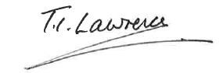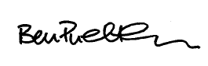
Ian Lawrence Ben Priestley
General Secretary National Officer
Napo UNISON

