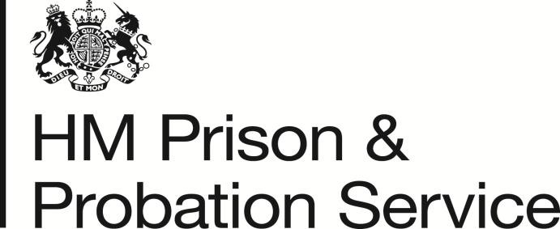

Michael Spurr
Chief Executive
HM Prison & Probation Service

Email:

Ian Lawrence, General Secretary, Napo
Ben Priestley, National Officer, UNISON
George Georgiou, National Officer, GMB/SCOOP
16 February 2018

Dear Ian, Ben and George

National Probation Service – Pay Award 2017

Further to our recent meetings, I am now writing formally to confirm our final position on the Pay Award for 2017.

I sincerely regret the protracted nature of the process for the 2017 pay award. This was in part due to the PRB process but also reflected our desire to achieve agreement as far as possible in light of the strong representations you made for a pay uplift for all your members. As I shared when we met, I am particularly mindful of the exceptional work that those you represent do on a daily basis in the most challenging of circumstances. The representations that you made during detailed negotiations made this case strongly. In the end, however, I’m afraid we have not been able to agree all aspects of the case which you made and the pay outcomes for NPS staff for 2017 will therefore be an increase of 1 pay point to 6,980 eligible employees below their payband maximum in pay bands 1 to 6 and A to D as of 1 April 2017. As you know, payment was made in April 2017 salaries and in addition, allowances that are linked to salaries were also uplifted.

Throughout the negotiations you have sought an increase for Probation colleagues at the top of their respective paybands. We understand and acknowledge your position and have considered this carefully and in good faith. Regrettably, however, I must now confirm that we do not propose to implement any increase for Probation colleagues at the top of their respective paybands for 2017. Effectively HMPPS has already exceeded the 1% pay remit for staff across the Agency for 2017 and providing a non-consolidated payment for staff at the top of their incremental scale would further increase Agency pay costs above the 1% and require exceptional approval from the Treasury, which is not available to us.

In these circumstances our considered approach is to now conclude the 2017 Pay Round and to concentrate our efforts on 2018/19, in order to introduce significant pay reform and a new pay system for the NPS, and in line with the recognition that greater flexibility on pay may be required in some parts of the public sector. This means that we do not propose to make any award to NPS staff at the top of their paybands for 2017 but instead will seek to address concerns about pay through a revised and reformed pay system in 2018/19.

As we have discussed, and you have made clear, I absolutely recognise that this will be very unwelcome news in the short term, but as you recognise the current Probation pay system requires fundamental reform and I am confident that we can negotiate an improved system which will bring more benefits to both your members and to the National Probation Service overall. I’m conscious that this is something which you and your members have been keen to pursue and I do appreciate the considerable patience you have shown in waiting for agreement for such talks to take place.

As I shared when we met, I believe the case for pay flexibility to enable us to implement revised pay structures in 2018 is compelling and I am confident we will be able to proceed to initiate a new pay system later this year.

I hope therefore that the disappointment which you will have about this year’s pay outcome will be mitigated by our clear commitment to negotiate a revised Pay System in 2018 which will properly take account of the need to motivate and retain our most experienced Probation staff as well as providing a revised pay structure which attracts new recruits and motivates them to progress within the Service, I do believe that this presents a real opportunity for the NPS and for your members and I would be happy to meet to discuss the way forward at your earliest convenience.

Yours sincerely,

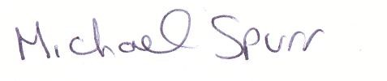

MICHAEL SPURR

