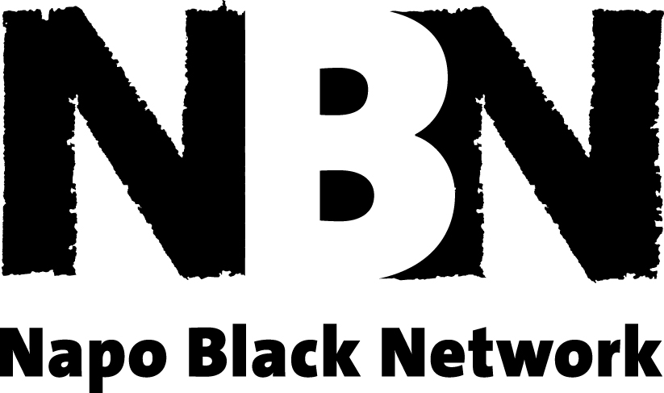


NBN MANIFESTO

Introduction

Napo opposes discrimination in all its forms and is committed to combating racism and oppressive practice, in both, the workplace and within its union structures.

The term ‘Black’ is used in its political sense, even though the group has a racially diverse membership. The use of the term ‘Black’ is meant to be inclusive and not exclusive, and we recognise that individuals may describe themselves in different ways.

Aims

- To be a peer support group that will provide support and guidance on matters of individual or collective concern to black members, particularly in relation to their experiences of working in the Probation Service and CAFCASS and as members of Napo.

- For the network to contribute to the decision making process in Napo and influence the development of Napo policy.

- To be an objective representative to the Probation Service and CAFCASS with regards to the services they deliver to the diverse communities they serve.

Objectives

- To be a safe and empowering environment for black members to raise issues about their experiences of employment within Probation and CAFCASS.

- To provide an opportunity to communicate with colleagues and promote solidarity to reduce feelings of isolation.

- To offer support to members who experience harassment and discrimination. To promote and signpost professionals and processes that can empower them with their issues.

- To share experiences with members and disseminate information by highlighting the positives and addressing the negatives.

- To share information with Napo on the views of the network at regular intervals.

- To encourage and support the involvement of network members in elected posts within Napo.

- To review this manifesto on an annual basis.

