4 Chivalry Road, London, SW11 1HT
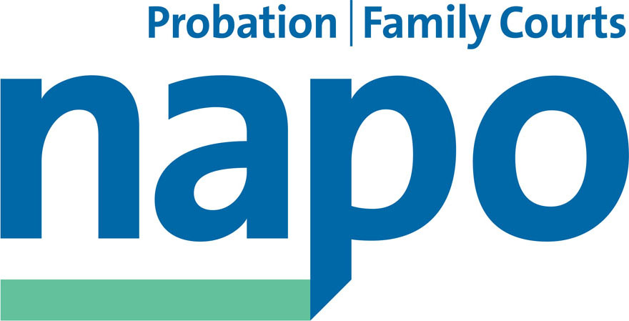

Telephone 020 7223 4887
Fax 020 7223 3503

www.napo.org.uk
Email: info@napo.org.uk

NEC 01/2017
IL/AV

Operational Plan 2017

Introduction

Please find attached Napo’s Operational Plan for 2017. The plan is based on Napo’s ongoing strategic aims and objectives and references resolutions passed at the Cardiff AGM.

Napo’s work as set out in the 2016 plan is described in the 2015/16 Annual Report.

This plan has been considered by the Officers and staff at Chivalry Road and was approved by the NEC at its November meeting.

Yours sincerely

IAN LAWRENCE
General Secretary

Napo's Objectives 2017

Objective 1: Promoting and protecting members' interests

Securing the promotion and protection of members’ interests at work. This objective includes the maintenance of Cafcass as a public sector service and campaign for the reinstatement of a national, amalgamated public Probation Service, with job security, decent and fair pay, pensions and conditions with national collective bargaining, fair and measurable workloads, equality, health and safety and representation. Ensuring the best use of Napo’s income via sound financial planning and regular monitoring of budgets.

Probation

- Pursue equal pay issues as part of the 2016/17 Pay Claim (AGM Resolution 3)
- Secure national agreement with employers on a fair and uniform method of applying obligations for time off for trade union duties and ‘facility time’ across all areas (AGM Resolution 12)
- Oppose any attempt to break up national collective bargaining and launch a campaign amongst members in any CRC that threatens to withdraw from current NNC/SCCOG arrangements (AGM Resolution 15)

Cafcass

- Pursue a pay settlement in line with the union’s negotiating objectives
- Oppose the Children and Social Work Bill (AGM Resolution 8)

Probation and Cafcass

- Monitor Napo’s new Members’ Services package provided by Parliament Hill
- Revisit Napo’s funding to the Edridge Fund (AGM Resolution 1)

Health and Safety

- Highlight the issues of the menopause for women in the workplace; promote sickness absence procedures which can take account of menopause related sickness absence; encourage openness and discussion amongst women members; promote training/awareness raising about menopause within probation and Cafcass (AGM Resolution 9)
- Join the European wide campaign against the TTIP (Transatlantic Trade and Investment Partnership) free trade treaty (AGM Resolution 10)
- Develop guidance for members advising on their rights and responsibilities if / when lone working (AGM Resolution 11)

Objective 2: Formulating Professional, Training and

Developmental Policies

Promoting the best professional policies, training and development, and qualifications in Probation and Cafcass, based on anti-discriminatory practice and a fundamental commitment to diversity. Providing advice and guidance to members and ensuring regular monitoring and evaluation of policy and practice. Promoting the professional association aspect of Napo.

Professional

- Resist the proposed changes put forward through the Effectiveness, Efficiency and Excellence (E3) Programme for Probation Officers seconded into YOTs (AGM Resolution 14)
- Reassert the importance of high quality pre-sentence assessment as critical to sentencing and the safe allocation of cases (AGM Resolution 17)
- Continue to provide responses to NOMS’ draft Probation Instructions

Training

- Correct the unfair termination process by the Probation Qualifications Advisory Board (PQAB) (AGM Resolution 13)
- Continue to support the work of the Union Learning project in Wales.

Objective 3: Campaigning and Communicating

Maintaining Napo’s high profile in successfully campaigning, promoting and communicating Napo’s policies and values. Organise the re-instatement of a national, amalgamated public Probation service and keep Cafcass as a public service, both with sufficient resources to guarantee jobs and service delivery. To work with unions, relevant organisations, MPs, Assembly Members, peers, parliamentary groups and others as appropriate in relation to wider public service campaigns.

Campaigning

- Join the ‘Together for Children’ Campaign to oppose the Children and Social Work Bill and to campaign with the Parliamentary Family Justice Committee to highlight the dangers inherent in this proposed Bill (AGM Resolution 8)
- Continue to expose the disastrous consequences of the Transforming Rehabilitation programme (AGM Resolution 4)
- Gather examples and widely publicise examples of deterioration in gathering, assessing and sharing information essential to risk management and safeguarding (AGM Resolution 16)
- Continue to campaign for the abolition of the Sodexo Booths (AGM Resolution 2)
- Continue to develop a unifying workloads campaign strategy, with the pursuit of accurate workload timings and development of a workload measurement tool that accurately reflects the work (AGM Resolution 5)
- Support the Labour Party, led by Jeremy Corbyn, in any campaign which includes the re-instatement of a national, amalgamated public Probation service (AGM Resolution 6)
- Continue joint campaigning with other unions, including the TUC, GFTU and TUCG
- Continue the fight against the political threat posed by fascist and far right groups

Communication

- Continue to produce and revise the Napo Quarterly magazine, including widening use of the online Napo News site
- Provide regular briefings and statements to parliamentarians and the print and broadcast media; send regular e-bulletins to branches on campaigning issues
- Support and promote the Probation and Family Court Journals, and occasional monographs and improve accessibility
- Continued use of improved Napo website as a primary interface with members, utilise learning and development components, interactive elements such as the forums and continue to increase the use of new technology like Facebook, Twitter and YouTube (NapoTV)

Objective 4: Building a strong, accessible and inclusive union

Prioritising the organising and recruitment strategy to provide growth in membership representative of all staff in Probation and Cafcass. Promoting structural reform that improves efficiency, democracy and accessibility. Providing trade union education and lifelong learning which empowers members and engenders union activity and organising specialist conferences for members.

Implementing and reviewing progress in relation to policy and action to combat racism, homophobia and heterosexism, sexism, transphobia, ageism, oppression based on religion/beliefs and promoting the social model of disability to combat oppression and discrimination. Promoting full equality and opportunity for all members. Ensuring that Probation employers and Cafcass keep equality and diversity at the heart of their structures promoting best practice and policy.

Trade Union Organisation

- Reform the functioning of the National Executive Committee (AGM Resolution 18)
- Amend the constitution and application process to permit agency staff to be full members of the union (Constitutional Amendment 1)
- Amend the constitution to change the quoracy for general meetings (Constitutional Amendment 2)
- Maintain and support the National Representation Panel and organise a recruitment process when necessary

Equal Rights

- Develop a campaign around hidden disabilities (AGM Resolution 7)
- Continue to develop the Napo Black Network and maintain close working relationship with remaining staff associations ABPO and NAAPS and build links with the newly developed NOMS’ staff networks
- Plan the next WiN conference
- Continue with monitoring statistics of speakers at the AGM

Training Courses, Seminars, Conferences and Events

- Organise AGM in Nottingham – 13 and 14 October 2017
- Provide a full range of trade union education/health and safety/union learning/equality and diversity courses which include accredited training
- Organise specialist/professional conferences and seminars (eg Family Court, The Forum, Managers) for members in Probation and Cafcass taking account of any review of current arrangements and financial savings
- Enable representation at TUC Congress and the TUC equality conferences
- Ensure that all events are accessible to all members to enable them to be representative of the diversity of membership

Objective 5: Acting as an effective and responsible employer

committed to equal opportunities

Ensuring the maintenance of an efficient and modern Napo head office by promoting equality and trust and supporting and developing staff. Acting as a good equal opportunities employer committed to consultation, negotiation and collective bargaining, valuing diversity and the contribution of staff. Ensuring that the recruitment and selection of staff is based on these same principles.

Using all resources, including information databases and technology, finance and membership services, in the most effective way in support of Napo’s objectives.

- Sale of Chivalry Road (Napo head office) and complete the move to 160 Falcon Road
- Follow up on actions identified from the Napo staff Training Programme in identified sub groups: Premises, ICT, ADR, Skills Audit and Stress Audit
- Review and develop a new Annual Development Review (ADR) process and identified training (as identified in the training programme and for the sub group to take forward)
- Hold monthly staff meetings, monthly administrator, bi-monthly Officers’ and Officials’ and weekly administrator workloads meetings
- Maintain involvement of union shops in employment related issues
- Continue the review and update of all Red Book policies
- Provide equality and diversity, ADR (under review), Health & Safety, Dignity at Work, and Recruitment & Selection training to all staff as required
- Continue working to (currently under review) financial procedures to ensure sound financial planning and regular monitoring of budgets
- Continue to update the membership system and data
- Look at new ways of holding meetings via Skype

