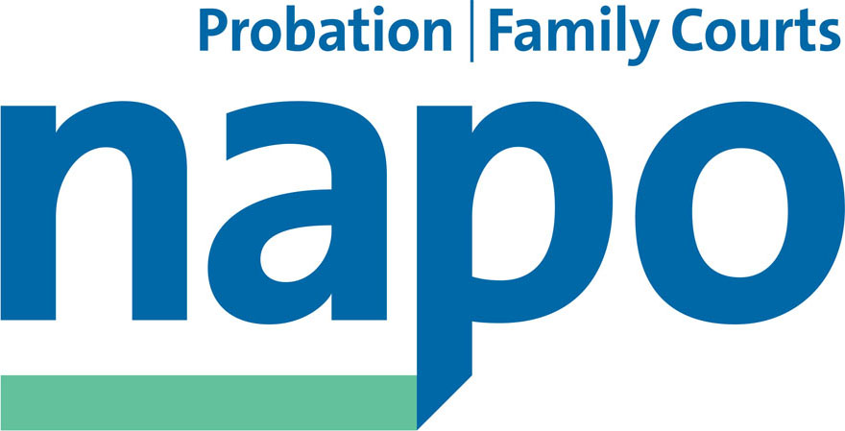

Press Release –
immediate release

Union anger at news of massive job cuts by private Probation supplier

Officials representing Napo members employed by the three Community Rehabilitation Companies (CRCs) covering Wales and the South West of England, have reacted angrily to news that the owner Working Links, intends to shed approximately 600 jobs from its workforce next year.

The news of an intended 40% cut in staffing within the organisation, who manage low and medium risk of harm probation clients in Wales, Dorset, Devon and Cornwall, Bristol, Gloucester, Wiltshire and Somerset, were revealed by Working Links at a meeting with the unions earlier last week. It was claimed that the cuts were necessary owing to a fall in the numbers of offenders who were expected to pass through the supervision process since the private contracts were signed in February.

Napo General Secretary Ian Lawrence said: 'Our members will be disillusioned and disgusted by the extent of these intended job cuts. They follow the shambolic imposition of the TR project, and are a desperate measure to ensure that Working Links remains profitable for the benefit of their shareholders but at the expense of the proper supervision of offenders. Napo will seek to engage in consultation and negotiation, but we start from a position of total opposition to these plans, which pose a real and present risk to safety in the relevant local communities, and which will have a devastating impact on the local economy.'

No official figures for the drop in offenders have been published at this stage and the Unions remain very skeptical that the forecast by Working Links is accurate. The Offender Rehabilitation Act came into force 1st February 2015 and the MOJ's own figures showed an additional 45,000 offenders would be subject to probation supervision following release from prison each year.

Immediately following the meeting with management, Napo representatives resolved to campaign against the job cuts via Parliament and the Welsh Assembly, and asked that plans should also be drawn up by their National Officials for possible industrial action.

Ends

Editors notes:
Transforming Rehabilitation (TR) began 18 months ago and saw the 35 probation trusts dissolved and replaced with a National Probation Service for high risk of harm offenders and 21 Community Rehabilitation Companies to supervise low to medium risk of harm offenders. 20 of the 21 are privately owned.

PR10-2015

