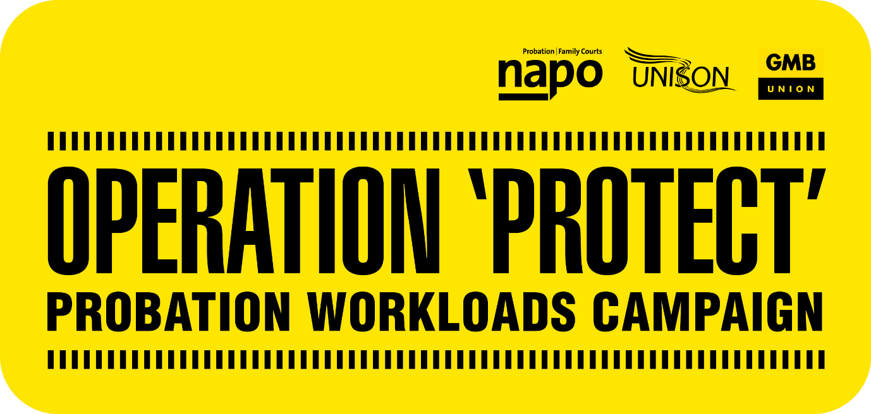

**PROBATION WORKLOADS CRISIS**

**WRITE TO YOUR MP**

To find your MP’s email address visit here: <https://members.parliament.uk/members/Commons>, if you don’t know your MP you can use your postcode to find their details here.

Using the model letter, remember to:

* Send the letter from your home email address, or via post. *Please do not send from you work email account.*
* Add your home address at the top of your letter as your MP will only respond if they know you live in their constituency.
* Please add your personal experience of the impact of excessive workloads.
* Add the contact details of your union, if you would like your MP to speak to us for further information: [info@napo.org.uk](mailto:info@napo.org.uk)
* Alternatively, you can request to meet your MP and we’d love to hear how those meetings go.

Please also send us a copy of the letter you sent, again at [info@napo.org.uk](mailto:info@napo.org.uk)